Document Issue: 1.2 Document Status: Final
Date Issued: April 11th, 2002 Filing Path:

Document Title: Simpsons 2 Game Design
Author: Joe McGinn, Shawn Lee
Keywords: Game Ideas, Gameplay Ideas, Feature Ideas

Revision History

Issue | Date | Person | Reason - include problem #, ECN #, etc.
0.1 | March 12, 2002 | Joe McGinn | Initial draft of document.
1.0 | March 15, 2002 | Joe McGinn | Final Preliminary Design (delivered to Fox March 15 2002)
1.1 | April 11, 2002 | Joe McGinn | Core Design (delivered to Fox April 15 2002)
1.2 | May 14th | Joe McGinn | 2nd pass core design
1.3 | June 14th | Joe McGinn | FINAL game design

Table of Contents
1 Simpsons 2 High Concept 9
1.1 Game Concept 9
1.2 Game Goals 9
1.3 Target Audience 9
1.4 Game Story 9
1.5 Gameplay Example 9
1.6 Game Modes 11
1.7 Major Gameplay Features 12
1.8 Game Worlds 12
2 Story 13
2.1 Product Goals 13
2.2 Story Goals 13
2.3 Summary 13
2.4 Act One (Intro) 13
2.5 Act Three (End Game) 14
3 Characters and Vehicles 15
3.1 Characters 15
3.2 Vehicles 16
4 Vehicle Chase AI 17
4.1 Goals 17
4.2 Prioritized Features 17
4.3 Tools 20
4.4 Content 20
5 Vehicle Escape AI 21
5.1 Goals 21
5.2 Prioritized Features 21
5.3 Tools 22
6 Truckasaurus Chase AI 23
6.1 Goals 23
6.2 Features 23
6.3 Art and Animation Features 24
6.4 Design Tools and Gameplay Tuning 24
7 Jumping Puzzles 25
7.1 Goals 25
7.2 Features 25
7.3 Questions 25
7.4 Level Design Tools 25
8 Collectibles 27
8.1 Goals 27
8.2 Features – In Car 27
8.3 Features – On Foot 27
8.4 Tools 27
9 Gameplay Controls 29
9.1 Goals 29
9.2 Features 29
9.2.1 PS2 Gamepad 29
9.2.2 X-Box Gamepad 30
9.2.3 Game Cube Gamepad 31
9.3 Tools 32
10 Switching Vehicles In Game 33
10.1 Goals 33
10.2 Features 33
10.3 Tools 33
11 Mission Scripter 34
11.2 Objectives 36
11.3 Sunday Drive Objectives 36
11.3.1 Example One – Get in to a Car 36
11.3.2 Example Two – Talk to Two People 36
11.3.3 Example Three – Get into a Car and Drive to Start Location 37
11.4 Gameplay Objectives 37
11.4.1 Failure Conditions 38
11.4.2 Other Attributes 38
11.4.3 Gameplay Example Objectives 39
11.5 Real-time AI Scripting 39
12 Missions 40
12.1 Goals 40
12.2 Mission Flow 40
12.3 Level Order 42
12.4 Level Direction 42
12.5 Level 1 - Evergreen Terrace 42
12.5.1 Training Missions 1 through 9 42
12.5.2 L1M1 CHASE – Drive the Car 43
12.5.3 L1M2 COLLECTION ON FOOT – Chase AI, Vehicle Damage 43
12.5.4 L1M3 CHASE – High Speed Starts 44
12.5.5 L1M4 COLLECTION ON FOOT – Vehicle Countermeasures 44
12.5.6 L1M5 CHASE & DESTROY– Destroy an AI Vehicle 45
12.5.7 L1M6 COLLECTION ON FOOT – High Speed Cornering 45
12.5.8 L1M7 COLLECTION IN CAR – Destroy Objects 46
12.5.9 L1M8 CHASE – High Speed Chase 47
12.5.10 L1M9 BOSS 1 47
12.5.11 Game Clock for Level 1 48
12.6 Level 2 – Squidport 48
12.6.1 L2M1 COLLECTION IN CAR – Destroy the Shipment 48
12.6.2 L2M2 CHASE & DESTROY – Destroy a Group of Vehicles 48
12.6.3 L2M3 COLLECTION ON FOOT – The Goose Chase 49
12.6.4 L2M4 CHASE – A Race 49
12.6.5 L2M5 COLLECTION ON FOOT – Drive on a moving BV 50
12.6.6 L2M6 COLLECTION ON FOOT 50
12.6.7 L2M7 CHASE – The Getaway 51
12.6.8 L2M8 BOSS 2 51
12.6.9 Game Clock for Level 2 52
12.7 Level 3 – Downtown 52
12.7.1 L3M1 COLLECTION ON FOOT – The Runaround 52
12.7.2 L3M2 CHASE – Follow the Leader 52
12.7.3 L3M3 CHASE & DESTROY – Destroy Vehicles 53
12.7.4 L3M4 COLLECTION ON FOOT – Lost and Found 53
12.7.5 L3M5 CHASE – A Race 54
12.7.6 L3M6 COLLECTION IN CAR – Destroy objects 54
12.7.7 L3M7 CHASE – Chase a Vehicle 55
12.7.8 L3M8 BOSS 3 55
12.8 Level 4 – Power Plant 56
12.8.1 L4M1 COLLECTION ON FOOT – Going Inside 56
12.8.2 L4M2 COLLECTION IN CAR – The Trains and the Plant 56
12.8.3 L4M3 COLLECTION ON FOOT – The Key Hunt 57
12.8.4 L4M4 CHASE & DESTROY – Destroy the Vehicles 57
12.8.5 L4M5 COLLECTION ON FOOT – Going Shopping 58
12.8.6 L4M6 COLLECTION IN CAR – 64 Bottles of… 58
12.8.7 L4M7 COLLECTION ON FOOT – The Grand Tour 59
12.8.8 L4M8 BOSS 4 59
12.9 Level 5 – Squidport 60
12.9.1 L5M1 COLLECTION ON FOOT – A New Place 60
12.9.2 L5M2 CHASE – A Chase 60
12.9.3 L5M3 COLLECTION ON FOOT – Find the People 61
12.9.4 L5M4 CHASE & DESTROY – Destroy Vehicles 61
12.9.5 L5M5 COLLECTION IN CAR – Destroy Objects 62
12.9.6 L5M6 CHASE – Race Up the Hill 62
12.9.7 L5M7 COLLECTION ON FOOT – Another New Place 63
12.9.8 L5M8 BOSS 5 63
12.9.9 Game Clock for Level 5 64
12.10 Level 6 – Downtown 64
12.10.1 L6M1 CHASE – A Race 64
12.10.2 L6M2 COLLECTION ON FOOT – A New Place 64
12.10.3 L6M3 CHASE & DESTROY – 3 Bad Guys 65
12.10.4 L6M4 COLLECTION IN CAR – Destroy Objects 65
12.10.5 L6M5 CHASE – A Chase 66
12.10.6 L6M6 COLLECTION ON FOOT – Another New Place 66
12.10.7 L6M7 CHASE & DESTROY – A Tough Vehicle 67
12.10.8 L6M8 BOSS 6 67
12.11 Level 7 – Power Plant 67
12.11.1 L7M1 COLLECTION ON FOOT – A New Place 68
12.11.2 L7M2 COLLECTION IN CAR – Shopping 68
12.11.3 L7M3 COLLECTION ON FOOT – Another New Place 69
12.11.4 L7M4 CHASE & DESTROY – Destroy Vehicles 69
12.11.5 L7M5 COLLECTION ON FOOT – Get the Goods 69
12.11.6 L7M6 COLLECTION IN CAR – Stadium Loop 70
12.11.7 L7M7 COLLECTION ON FOOT – Find the … 70
12.11.8 L7M8 BOSS 7 71
12.12 Level 8 – Evergreen Terrace 71
12.12.1 L8M1 CHASE – A Race 71
12.12.2 L8M2 COLLECTION IN CAR– Beat ‘em Up 72
12.12.3 L8M3 COLLECTION ON FOOT– Someplace New 72
12.12.4 L8M4 BOSS 8 – The Final Boss ??? 73
12.12.5 L8M5 COLLECTION ON FOOT – Get the Goods 73
12.12.6 L8M6 CHASE & DESTROY – Catch the Race Vehicle 74
12.12.7 L8M7 CHASE – The Race 74
12.12.8 L8M8 COLLECTION ON FOOT – The Big Finish 75
12.12.9 Game Clock for Level 8 75
12.13 Appendix A - The Toolbox (Mission Components) 76
12.14 Appendix B – Mission Templates 77
13 Boss Level Examples 78
13.1 Boss 1 – Guarding an Object 78
13.2 Boss 2 – Through a Maze 78
13.3 Boss 3 – Cage the Truckasaurus 78
13.4 Boss 4 – The Homer-saurus 79
13.5 Boss 5 – Guarding a Place 79
13.6 Boss 6 – Cage the Truckasaurus 79
13.7 Boss 7 – Through a Maze 80
13.8 Boss 8 – Kill the Truckasaurus 80
13.9 Appendix A – Boss Animation 80
14 Multiplayer 83
14.1 Goals 83
14.2 Prioritized Features 83
14.3 Question 85
14.4 Tools 86
14.5 Prioritized Content List 86
15 Driving Model 87
15.1 Goals 87
15.2 Features 87
15.3 Tools 88
16 Collision Physics 89
16.1 Goals 89
16.2 Features 89
16.3 Design Notes 90
17 Dialog System 91
17.1 Goals 91
17.2 Definitions 91
17.3 Conversations 92
17.4 In Car One Liners 92
17.4.1 Driver/Walker 92
17.4.2 Walker Only 93
17.4.3 Driver Only 94
17.5 On-Foot One Liners 94
17.5.1 Walker Only 94
17.5.2 Pedestrian 94
17.5.3 Pedestrian Only 95
17.6 Multiplayer Events 95
18 Sound 97
18.1 Goals 97
18.2 Voice 97
18.2.1 Direction 97
18.2.2 Type definition 97
18.2.3 Implementation / Tool requirements 97
18.2.4 Risks / Concerns / Problems / Solutions 98
18.3 Car sfx 98
18.3.1 Direction 98
18.3.2 Type definition 98
18.3.3 Implementation / Tool requirements 99
18.3.4 Risks / Concerns / Problems / Solutions 99
18.4 SFX 100
18.4.1 Direction 100
18.4.2 Type Definition 100
18.4.3 Implementation 100
18.4.4 Tools requirements 101
18.4.5 Risks / Concerns / Problems / Solutions 101
18.5 Music 101
18.5.1 Direction 101
18.5.2 Type definition 102
18.5.3 Implementation 102
18.5.4 Risks / Concerns / Problems / Solutions 102
18.6 Front End 103
18.6.1 Direction 103
18.6.2 Type definition 103
18.6.3 Implementation / Tool requirements 103
18.6.4 Risks / Concerns / Problems / Solutions 103
18.7 Ambient and Landmark Sounds 103
18.7.1 Direction 103
18.7.2 Type Definition 103
18.7.3 Implementation / Tool requirements 104
18.7.4 Tools 104
18.8 NIS / FMV 104
18.8.1 Direction 104
18.8.2 Type definition 104
18.8.3 Implementation / Tool requirements 104
18.8.4 Risks / Concerns / Problems / Solution 104
18.9 Memory management 105
18.9.1 PS2 105
18.9.2 X-BOX memory management 105
18.10 Additional Features 105
18.10.1 Reverb 105
18.10.2 Dolby Surround 105
19 Presentation 107
19.1 Goals 107
19.2 Content 107
19.3 Features 108
19.4 Tools 111
19.5 Character Animations 111
19.5.1 Idle Animations: 111
19.5.2 Mission Failure (on-foot) 113
19.5.3 Mission Failure (in Car) 113
19.5.4 Mission Success (on-foot) 114
19.5.5 Mission Success (in-Car) 115
20 Animation 116
20.1 Goals 116
20.2 Features 116
20.3 Content 116
20.3.1 Eight Walking (User Controllable) Characters 116
20.3.2 Sixteen Drivers 117
20.3.3 Passenger Animations 117
20.3.4 Pedestrian Animations 118
21 Game Interface (HUD & Map) 119
21.1 Head Up Display (HUD) 119
21.1.1 Goals 119
21.1.2 Features 119
21.1.3 Tools 120
21.2 Player Navigation (Map) 120
21.2.1 Goals 120
21.2.2 Features 120
21.2.3 Design Notes 121
21.2.4 Tools 121
22 Front End Interface 122
22.1 Goals 122
22.2 Features 122
22.3 Controls 122
22.4 Flow 124
22.5 Continue Latest Game 125
22.6 New Game 125
22.7 Load Game 125
22.8 Select Mission 127
22.9 Multiplayer 127
22.10 Options Menu 127
22.11 Pause Menu (Single Player) 128
22.12 Pause Menu (Multiplayer) 130
22.13 Memory Card (TRC Requirments) 131
22.14 Menus 131
22.14.1 Generic 131
22.14.2 Memory Card 131
22.14.3 Main Menu 131
22.14.4 Multiplayer 131
22.14.5 Options 131
22.14.6 Game Over 132
22.14.7 Total = 36 132
22.15 Tools 132
22.16 Content 132
23 Memory Card & TRC Interface 133
23.1 Goals 133
23.2 Boot Up Process 133
23.2.1 Error Handling Process 135
23.3 Load Game 137
23.4 Save Game 139
23.4.1 Appendix A (Error Handling messages for Game Cube) 140
23.4.2 Appendix B (Error Handling messages for PlayStation 2) 140
23.4.3 Appendix C (Error Handling messages for Xbox) 141

Simpsons 2 High Concept

Game Concept

Simpsons 2 is a duel-genre Simpsons game: mission-based driving and character-based action/adventure. In vehicles and on foot you’ll find chases, escapes, and other exciting missions. The game is the interface – everything from finding missions to switching vehicles takes place in a lifelike version of Springfield.

Game Goals

- Fun to play without the Simpsons content
- Fast instant action with room for skill
- Authentic Simpsons product

Target Audience

- Casual gamers who enjoy arcade-style gameplay
- Fans of The Simpsons, of all ages
- Driving game fans

Game Story

Kang and Kodos come to earth to tape and transmit a reality television show based on Springfield back to their home planet, but for much of the game the player and the townspeople have no idea that they are there. As the game progresses, Kang and Kodos and their show will be discovered. The game will then transition to the final Evergreen Terrace Halloween level where the player must stop Kang and Kodos’s show before the final episode—an episode where Kang and Kodos plan on destroying Springfield.

Gameplay Example

You are playing as Homer and begin the game standing outside of the Simpsons’ house. You move Homer with the analog stick with camera-relative controls (i.e., push the stick in the direction you want Homer to move). You can him tip-toe, walk, or run based on how far you push the analog stick. You experiment with your controller and find that you can make Homer jump by pressing the A button, and you can rotate the camera with the right thumbstick.

Homer’s pink sedan is in the driveway so you walk over to it. A text message appears on the screen telling you to press the Y button. You press it and Homer gets into the car. It starts up with a roar and the camera moves to the driving position, behind and slightly above the car.

You use the left and right controller triggers to make the car stop or go, and you steer with the left thumbstick. It drives almost like a rally-style game as you slide the car around corners and dip in and out of traffic. You get in an accident and the car becomes damaged, and the trunk opens and closes as you drive. You clip a car as you race though an intersection, and the trunk pops off your car entirely.

Your HUD map is directing you to a nearby location. You see it is the Kwik-E-Mart, and Moe is sitting in a delivery truck in the parking lot. There is a comic-book-style “talk icon” over his head. You swing the car to a stop and press the Y button. Homer gets out of his car. You walk over to Moe and press Y, and Homer hops into the passenger side of Moe’s truck.

“Hi Moe,” Homer says.

“Homer! Am I glad to see you. I need two crates of cough syrup right away. But the Kwik-E-Mart is closed! Can ya help me out?”

“Sure … wait a minute. You’re not making Flaming Homers and calling them Flaming Moes again are you?”

“Heh,” Moe says nervously. “No no … I just … uh … had a throat transplant and uh, it’s really sore, OK?”

“Well all right then.”

The camera zooms in on Moe and freezes. The mission objectives appear on the screen with a “Press A to Continue” message. You press A and the mission begins.
Moe’s truck feels very different from Homer’s car. Slow and ponderous, it’s harder to dodge traffic. But when you hit a car there’s less damage and impact on your truck. You race across town, ignoring all laws, and start to attract attention. Two police cars swing into pursuit with sirens blaring.

You try to hold them off as they batter your truck, trying to knock you off the road. The truck is too slow to outrun them. You detour down a narrow alley to see it’s a dead end – except for a narrow ramp that leads over a fence. You carefully maneuver the truck to keep it on the ramp and leap to your escape, landing right in the Try’n’Save parking lot.
You press Y and Homer jumps out. You run over to the store and collect the crates of cough syrup. Homer celebrates as “Mission Success” is displayed on the screen.

You’re about to head back to Moe’s truck to go and find your next mission when you see Apu driving down the street in his red sports car. You run in front of his car and press Y. Apu stops and Homer gets in.

This vehicle is fast and dangerous, so you enjoy a few minutes of exploring the expansive game level. An icon on your HUD map marks the next mission. As you’re heading towards it you see something interesting – a stack of boxes in a stair-like formation on a small building near Moe’s bar. You get out of the car and jump up the boxes by pressing A. There’s a gap of several meters across an alley to the roof of Moes. You try to jump it and can’t make the distance; you fall to the alley below.

You climb back up on the building. You take a more careful look and see a garbage truck moving back and forth in the alley. It looks just close enough. You wait for the right timing, jump, and land on the truck. When it gets near Moes you jump again and land on Moe’s roof. Here there is an old microphone in a stand, and a glowing, rotating object. You walk into it and Homer says, “Hey, it’s my old group!”

The object expands to show you that it’s a Be-Sharps record album from Homer’s barbershop quartet days with Apu, Barney, and Principal Skinner. Text on the screen tells you “Secret bonus object found!” The object goes into your inventory where you can view it later. You hop off the roof and look for a ride to your next mission…

Game Modes

- Story Mode. The Game is the Interface – no load-times within a game level. Play as a character through a mission-based story. Move seamlessly from vehicle to vehicle, or out of the car for conversations and on-foot gameplay.
There are eight episodes, each of which takes place in one of four levels. Each level will be used twice, at two different times of day. Each level will take about an hour for an average gamer to complete. A FMV movie plays at the beginning and end of each level.
The user will always be directed to the next objective they need to complete in order to move through the story, but they will also have time for exploration. The things you will do in the game:
In-Car | - Chase and disable other (AI) vehicles  - Escape from vehicles chasing you  - Destroy objects
On Foot | - Collect objects – find unlockables and bonus characters  - Jumping puzzles  - Talk to characters  - Switch to different vehicles

- Head to Head – Capture The Flag (CTF)
A new version of Road Rage CTF gameplay. The improvements will include:
- Focus on player contact and battles:
  - Smaller, tighter game level
  - “Bullet Time” feature and camera work that emphasizes the battle
- Better visibility of opponent

Major Gameplay Features

- 2 genres integrated seamlessly:
  - Mission-based driving with AI chase & escape vehicles
  - On-foot jumping puzzles and bonus collectibles
- Play as eight Simpsons characters
- 40+ Simpsons characters in the game
- 16 drivable vehicles with real-time damage
- Outsmart the Truckasaurus in nine boss missions
- Dialog by the real character voice actors
- Story by The Simpsons TV show writers
- The Game is the Interface – no front-end menus for story mode

Game Worlds

The game will have four themed areas. Each will have two different times of day, two to three fully modeled landmark interiors (examples listed below) and dozens of other Springfield landmarks and locations.

Downtown
- Police station
- Android’s Dungeon (comic book store)
- Legitimate Businessman’s Social Club

Squid Port
- Moes
- Krusty Burger

Suburbs
- The Simpsons’ House
- Kwik-E-Mart
- Springfield Elementary School
- Springfield Church

Industrial
- Nuclear Power Plant
- Mr. Burns’ office
- The prison

Story

Product Goals
- Make people laugh
- Authentic Simpsons Experience
- Simpsons style of humor and delivery

Story Goals
- New stories that are authentic to characters’ relationship to experience
- Incorporate “one off” or “red herring” missions that have little or nothing to do with the story
  - Mix of what characters “would do” and “have done”
- Surprise the player
  - No predictability
- Should be engaging regardless of Simpsons license (in other words, have a sound story structure including setups of humorous situations)

Summary
Kang and Kodos come to earth to tape and transmit a reality television show based on Springfield back to their home planet, but for much of the game the player and the townspeople have no idea that they are there. As the game progresses, Kang and Kodos and their show will be discovered. The game will then transition to the final Evergreen Terrace Halloween level where the player must stop Kang and Kodos’s show before the final episode—an episode where Kang and Kodos plan on destroying Springfield.

Act One (Intro)
The first “walkable” (controllable) character takes the user through a series of eight short introductory missions set in the first level of the game: Evergreen Terrace. The missions have little to do with the main storyline, though very subtle references can be made. They not only serve to introduce the player to the mechanisms and controls of the game but also allow for a variety of missions that are separate from the theme of the rest of the game.

Act Two (Body)
The story changes to the main theme where there are a series of “strange” happenings in the town; e.g., cows are missing, characters disappear, very bizarre Simpsons-themed crop circles appear, and electronics randomly fail or act erratically. The core characters investigate and try to discover the reason behind these occurrences. The missions have a theme in style with The X-Files, “V”, Close Encounters of the Third Kind, etc. Act two ends with the revelation that the aliens are in town to transmit a reality television show over intergalactic airwaves.

Act Three (End Game)
The final act of the game builds to the season finale of the alien reality show that will be filmed during Halloween in which Kang and Kodos transform Springfield and its denizens into a Treehouse of Horror style world complete with zombies, ghosts, and other Halloween paraphernalia. In the final missions, it is revealed that an intergalactic vote will be cast whether or not to destroy the town--the final tasks require the user to destroy the transmitters relaying the signal and to free the town of the alien presence (chasing them to Shelbyville).

Characters and Vehicles

Characters
Character | Role | Voice Actor | New/Redo
Homer | walker/driver | Dan Castellaneta | Redo
Marge | walker/driver | Julie Kavner | Redo
Apu | walker/driver | Hank Azaria | Redo
Frink | walker/driver | ? | Redo
Bart | walker/driver | Nancy Cartwright | Redo
Lisa | walker | Yeardley Smith | Redo
Ralph Wiggam | walker | Nancy Cartwright | Redo
Milhouse | walker | Pamela Hayden | Redo
Snake | driver | Hank Azaria | Redo
Frink | dirver | Hank Azaria | Redo
Comic Book Guy | driver | Hank Azaria | Redo
Chief Wiggam | driver | Hank Azaria | Redo
Krusty | driver | Dan Castellaneta | Redo
Otto | driver | Harry Shearer | Redo
Moe | driver | Hank Azaria | Redo
Waylon Smithers | driver | Harry Shearer | Redo
Ned Flanders | driver | Harry Shearer | Redo
Barney | pedestrian | Dan Castellaneta | Redo
Bumble Bee Man | pedestrian | Hank Azaria | Redo
Burns | pedestrian | Harry Shearer | Redo
Dr. Hibbert | pedestrian | Harry Shearer | Redo
Dr. Nick Rivera | pedestrian | Hank Azaria | Redo
Groundskeepre Willie | pedestrian | Dan Castellaneta | Redo
Hans Moleman | pedestrian | Dan Castellaneta | Redo
Jasper | pedestrian | Harry Shearer | Redo
Kent Brockman | pedestrian | Harry Shearer | Redo
Maggie | pedestrian | --- | Redo
Mayor Quimby | pedestrian | Dan Castellaneta | Redo
Mr. Plow | pedestrian | Dan Castellaneta | Redo
Nelson Muntz | pedestrian | Nancy Cartwright | Redo
Patty | pedestrian | Julie Kavner | Redo
Selma | pedestrian | Julie Kavner | Redo
Principle Skinner | pedestrian | Harry Shearer | Redo
Reverand Lovejoy | pedestrian | Harry Shearer | Redo
Rod Flanders | pedestrian | Pamela Hayden | Redo
Todd Flanders | pedestrian | Nancy Cartwright | Redo
Sea Captain | pedestrian | Hank Azaria | Redo
 |  | Total | 39
Cletus | driver | Hank Azaria | New
Kearny | pedestrian | Nancy Cartwright | New
Jimbo | pedestrian | Tress Macneille | New
Dolph | pedestrian | Tress Macneille | New
Carl | pedestrian | Hank Azaria | New
Lenny | pedestrian | Harry Shearer | New
Agnes Skinner | pedestrian | Tress Macneille | New
Lou | pedestrian | Hank Azaria | New
Eddie | pedestrian | Harry Shearer | New
Zombie1 | pedestrian |  | New
Zombie2 | pedestrian |  | New
Zombie3 | pedestrian |  | New
Generic Pedestrian 1 | pedestrian |  | New
Generic Pedestrian 2 | pedestrian |  | New
Generic Pedestrian 3 | pedestrian |  | New
Celebrity 1 | pedestrian |  | New
Celebrity 2 | pedestrian |  | New
Celebrity 3 | pedestrian |  | New
Celebrity 4 | pedestrian |  | New
Celebrity 5 | pedestrian |  | New
 |  | Total | 19

Vehicles
Speed:

Bart Ferrini no rooftop
Apu Trans Am no rooftop
Snake bandit no rooftop
Homer Barracuda No rooftop

Control:

Homer Pink Sedan No rooftop
Grampa WWII jeep No rooftop
Cletus pickup truck with Rooftop
Wiggum Police car with rooftop
Krusty clown No rooftop

Mass:

Marge Canyonero With rooftop sunroof
Otto Schoolbus With rooftop
Moe Duff Truck with Rooftop
Smithers Limo with Rooftop
Flanders motorhome with Rooftop
McBain Hummer with Rooftop

Vehicle Chase AI

Goals

This is the area of the game where we will “make or break” our overall gameplay goal: Game has to be fun to play without Simpsons license. The essence of chase AI is that these vehicles are player enemies – so the player must have effective tools for defeating them. The goals are:

- Effective strategies, tools, and counter-measures for defeating AI chase vehicles.
- Clear strategies and tools – the user must know what they are supposed to do.
- Visceral payoff for utilizing the strategies – use visuals, sound, controller vibration, camera (position, camera shake, etc.) and physics system (e.g., aftershock of explosion shakes player vehicle).
- Empower the user – e.g., create difficulty by the number of enemies, not by increasing their strength.
- Flexible AI that can be tuned by designers (e.g., location specific AI) but with runtime variables to control AI difficulty and numbers.
- Reasonable scope

Prioritized Features

- The golden rule – Player vehicle has a strength advantage over AI vehicles. One on one, the player can defeat an AI vehicle through sheer force.
  - An AI car will be disabled by any serious accident (e.g., impact over a certain threshold).
- AI vehicle start locations will be placed in Maya by designers on a mission-by-mission basis, with triggers that start them up.
- AI chase cars will also spawn as part of the AI traffic system, and chase the player if they get close to them (distance to be tunable). The density of this spawning will be controllable in real-time based on mission circumstances (e.g., picking up more collectibles increases density, but changing vehicles resets it to the default level).
- There are three types of AI vehicles:
  - “Generic” AI chase/escape vehicles; simple models without interiors or characters in them, there can be several of them chasing the user at once
  - “Boss” vehicles – basically a drivable vehicle, with fully rendered interior and a character in it (e.g., Wiggum in his police car). Only one of these will ever be present at one time
  - “Generic roadblock vehicles” – generic vehicles that do not drive when they are spawned, they are roadblock obstacles for the user to get around
- EXPERIMENT with camera system that shows as much of the chase as possible – pulls back and up to show more of what’s behind you (last year’s camera system should be mostly re-usable, except for the up/down camera damping effect – when was enabled it overrode the height of the camera).
- Driving strategies
  - Swerving through oncoming traffic greatly increases the chances of an AI accident.
  - AI vehicle line of site, or other ways you can hide from them? Maybe specific places for this, such as gas stations? If you get there when the AI can’t see you they go roaring by?
  - Outrun AI vehicles - through perfect driving and/or speed burst, or a tricky shortcut
  - Block AI vehicle with physics objects (large movables or traffic vehicles that have been knocked off their path). Has to be effective – AI should suffer a large penalty when they run into the objects.
  - Vehicle choice matters
    - Vehicles have a specialty of speed, control, or strength
- TO BE INVESTIGATED: vehicle speed bursts? Will this cause problems for dynamic loading?
- World counter-measures:
  - Jumps that change roads (e.g., onto or off of a bridge) make the AI crash or lose you
  - Narrow alleys difficult to get into at high speed
- Payoff for defeating AI:
  - Show the explosion/crash if we can - Bullet time in certain situations? E.g., jump escape?
  - AI Cars explode when they crash hard enough to be disabled. This has many effects:
    - Large visual explosion f/x (causes light flash you can see even if explosion is out of screen?)
    - HUGE explosion sound (think about breaking the sound barrier)
    - Camera shake
    - Controller shake
    - Aftershock hits user vehicle and causes back of vehicle to lift slightly (see bomb counter-measure effect in Smuggler’s Run 2 for example of this)
    - Vehicle parts go flying by (i.e., from behind) – an animation, not physics based
    - In convertible (e.g., Wiggum’s car) the AI driver goes flying by – animation or physics based? Harder to get approved by Fox/Gracie; so maybe lower priority?
    - Use bullet time as presentation effect in certain specific situations (e.g., you hit the jump – time goes slow, camera swings around to show police cars crashing as you fly to safety)
- General AI rules and principles:
  - Incorporate realistic reaction times into AI programming, so that they act like humans – provides more counter-measures, and could make bullet-time in single-player mode effective.
  - No cheating – AI has same controls and physics as the player.
  - The AI will have skill levels in three different categories, adjustable by the mission scripter:
    - Reaction time/skill – low, medium, or high
    - Numbers of AI – low, medium, high (affects AI calling for backup, and the number of cars that come to help)
    - Speed of AI – Fast, Medium, Slow (definitions? E.g., are they relative to the player’s current vehicle speed?)
    - Strength
- AI vehicle techniques to use against the player, with intended effect, and corresponding player counter-measure to prevent it from being frustrating.
AI Tactic | Intended Effect on User | Countermeasure / User strategy
Sideswipe you | Push user into something | - Hit brakes – AI shoots ahead  - Speed burst
Rear-swipe (i.e., hit near your back bumper) | Spin out | - Hit brakes or swerve  - Oil slick, smoke screen, bomb
T-bone (side collision) | Severe damage, loss of control | - Brakes or swerve – or quick brakes followed by gas, and t-bone the attacker  - Speed burst, bullet time
Head-on-collision | Most severe damage possible from one collision; kamikaze in nature (i.e., destroys the attacker too) | - Swerve/stop
Rear-end collision | Loss of control | - Swerve  - speed burst, oil slick, bomb, smoke screen
Impede – group of AI cars blocking you | Slow you down | ?
Impede – box you in | Slow you down | Brakes + swerve
Hit user (with an above technique) and back off | Put the user off balance, as AI changes to another tactic | - Evasive maneuvers  - Speed burst after being hit
Call for backup | Add other AI cars, with their own tactics
Call for a roadblock | Block the user on an upcoming path | - Steer through gap in roadblock  - Bullet Time

Tools

- Maya world-building:
  - Place start-locations and identity of AI chase vehicles. They are sitting their stationary until the user gets in a certain range, when they become active.
    - One set of start locations per mission (i.e., referenced by the mission scripter – which can also specify “no chase AI” for a mission).
    - One “fallback” set per level for non-mission situations, active when no specific mission set is referenced and “no chase AI” is not specified.
- Mission scripter:
  - Allows setting of AI difficulty level per mission, or possibly per specific situations (e.g., go to level two when the user picks up their fourth Panda bear”).
  - Allows chase AI to be turned off

Content

Special f/x:
- Big explosion effect for AI vehicles (also could be used on AI collisions in general) and related special f/x:
  - Sound, animation (vehicle parts), controller vibration, screen fade, and physics aftershock on the player vehicle

Vehicle Escape AI

Goals
- Promote re-use (i.e., higher priority for a system that can be used in different ways)
- Reasonable scope
- Fast and exciting gameplay – the model is the movie car chase (French Connection, Ronin, Bullet, etc.)
- Limit predictability of AI

Prioritized Features

- Disable an escaping vehicle
  - Vehicle on pre-defined path (but using AI to navigate obstacles in the world)
  - Choices in the vehicle path to reduce predictability (e.g., designers place the path, and specify where vehicle can make a choice about path)
  - Path can be point-to-point or looping
  - There can be more than one escape vehicle/path in a misison
  - Game variants that use the same tools/code:
    - Tag (touch an escaping vehicle)
    - Follow (don’t lose site – stay within a certain distance until you both reach a location)
  - AI vehicles give hints (e.g., turn signals – like the dumb criminals on “Cops” – we’d make a joke about it)
- Tunable AI parameters:
  - Top speed (could be used as simple race?)
  - Acceleration
  - Handling
  - Strength/durability
  - Reaction time/skill
- AI car identified with an arrow, and possible other f/x or glow (same system as used in Multiplayer)
  - Include simple damage meter (see Wreckless for example)
- AI vehicles escape strategies:
  - Swerve through oncoming traffic
  - Powerslides/tight turns
  - Knock physics objects/vehicles into your path
  - Very fast driving through busy streets
  - Use jumps
  - Use counter-measures? (smoke screens, oil slicks, etc) needs prototyping - could be frustrating

Tools

- Lay down AI paths in Maya, with choices for the AI vehicles to avoid predictability, e.g.:

- Would need to lay down in Maya:
  - User start location
  - AI vehicle identity and start location
  - Checkpoints for user navigation?
  - Checkpoints (including choices as shown above) for AI path
  - Finish area as a rectangular collision volume
- Mission scripting tool lets is specify “hunt and destroy” missions; logic for AI vehicle spawning in code

Truckasaurus Chase AI

Goals

- Add a high impact back-of-the-box “boss” mission type
- Relatively simple, low-tech AI
- One Truckasaurus mission per level
- Puzzle-orientation to the solution for most missions; once you figure out what to do, it won’t be very hard

Features

- The Truckasaurus acts like a T-Rex. If you are close to it, it will chase you. If you get to far away, it loses interest. If it catches you, you're toast.
- When it loses interest, it can either stand in place (with idle animations) or return to it's previous waypoint or start location (with “guarding” animation). This would be set as a mission parameter (i.e., he’ll work one way or the other for the entire mission).
- There will be one Truckasaurus mission per level.
- The Truckasaurus will NOT be required to have any specific knowledge of the world or how to navigate it. Therefore each mission will have one of the following attributes:
  - A world designed like a pen, with no static BVs that the Truckasaurus can get hung up on. In other words, he can walk in a straight line from any one point to any other point within the pen.
  - If he has to follow you through a more regular part of the game world, the designers will lay down a series of waypoints. The Truckasaurus will head for the next waypoint, or the player vehicle – whichever is closer.
- The Truckasaurus will essentially have “infinite mass” – no physics object can obstruct it.
- Like any character, the Truckasaurus can stand on platforms, including moving ones.
- There will be some special “victory/failure” conditions for certain missions, for example:
  - In a “cage the Truckasaurus” mission, you’ll have to get him into an areas (i.e., a trigger volume) and close the door before he can get out.
  - In the final mission, we will trigger a death-animation when your car strikes the upper-part of the Truckasaurus (i.e., you have to use a jump in the Stadium to hit him).
  - More to come…
- Investigate whether we can let the user control the Truckasaurus character, possibly using another character’s animation set (e.g., the Homer-saurus or Ralph-asaurus).
  - Does this cause camera or other problems with the world design?

Art and Animation Features

- Mission-start presentation/animation for the boss
  - The same for each mission? Or do we need some mission-specific ones?
- General running and turning
- Chase animations that give feedback on the luring gameplay:
  - Aggressive running (i.e., like in our movie)
  - Getting very close and taking swipes and bites at you
  - Loosing interest if you get too far
- "Guarding" animation (standing and guarding an object)
- Idle animations
- Victory/failure animations, e.g.:
  - He could crush your car in his jaws if he catches you?
  - What if you’re on-foot?
  - What if you get away/win the mission?
- We might have specific animations/NIS for traps:
  - Truckasaurus falling into the water
  - A second trap for boss mission 6?
  - Truckasaurus’ head gets knocked off in final mission?
- A Homer-saurus animation set - the Truckasaurus with Homer animations, i.e., he's in a motion capture suit. Pending technical investigation.
- A Ralph-asaurus animation set - the Truckasaurus with Ralph animations . Pending technical investigation.

Design Tools and Gameplay Tuning

- Truckasaurus waypoints will be placed with the same tool we use for evasion-AI-vehicle waypoints.
- Designers will need to tune:
  - Speed of the Truckasaurus (with some limitations, so that the animation still looks good)
  - The distance at which he first smells you (or loses interest if you get farther than this)
  - The distance at which he goes into aggressive-running animation
  - The distance at which he goes into taking-swipes-at-you animation
  - The distance at which he can kill you

Jumping Puzzles

Goals

- Give the characters an on-foot action
- Augment the on-foot collectible gameplay with a simple skill element

Features

- The eight walking character will have a jump animation & button
  - All characters will jump the same height & distance (TBD)
  - There will NOT be advanced jumping features such as characters pulling themselves up onto ledges, climbing ladders, or pushing/pulling objects
- Characters can jump onto animated b.v.s (platforms)
- Characters can be obstructed by animated b.v.s
- Characters can push a button that activates (or de-activates) an animated b.v.

Questions

- Need to determine the height and distance of jumps ASAP
  - What if the character is walking? How far do they jump?
- Need to determine if we need any new animations besides the jump itself (e.g., for mid-air collision with objects?)

Level Design Tools

Given very simple jumping functionality (jump, animated platforms, and buttons) we have the following set of tools to build jumping gameplay:

Jumping | Animated B.V.s | Buttons | Walking/Running
- “Climbing”(jumping up a series of boxes)  - Jump over obstacle or gap  - Avoid animated b.v.  - Jump onto animated b.v.  - Timing? | - Platforms  - Gates  - Elevators  - Infinite Mass (obstacle) | - Open gate  - Close gate  - Begin cycle | - Maze  - Accuracy (walk carefully)  - Avoid animated b.v.

Some of the “extra” features that we’ve decided to put on hold are:
- Pushing objects
- Chasing a pedestrian
- Climbing ladders
- Pulling self up onto object
- Stomp to brake something
- Jump + button-press button combo

Collectibles

Goals

- Simple – e.g., does not increase character animation scope
- Flexible – systems that can be re-used in many different contexts
- Payoff – collectible events that are satisfying in some way for the user will make the game feel less linear
- Easy to execute – simple, effective controls

Features – In Car

- Breaking things. Driving over a specific object (e.g., Mr. Burns mailbox because it contains Homer’s embarrassing letter) or one of a set of objects (i.e., like Road Rage missions).
- Graphical highlight or indication of collectibles. As well as being marked on the map, collectibles need to be highlighted on-screen (e.g., by glowing, or with a floating arrow pointing at it.

Features – On Foot

- Talk to a character who is holding a visible object. At the end of the conversation:
  - The object disappears (maybe with a procedural rotate/shrink animation?)
  - The user gets an object (not visually – it’s a sound effect plus HUD update).
- Flipping switches – a highlighted location in the world cause the physics animation of an object to be turned on or off (specified in a mission script). For example:
  - Press a switch that causes an ferry to start running back and forth across an area of water
  - Press a switch that starts (or stops) a drawbridge going up and down
  - Such an event might be required by a mission, or it might be an optional thing that you can do in the game world
- Get into another vehicle (see “Switching Vehicles” document)
- Find a bonus collectible in the game world
  - The objects will be represented by a 3d floating, rotating icon (e.g., Homer’s Mr. Plow jacket)

Tools

- World-building:
  - Place characters for a mission, with dialog and object associations
  - Place locators for breakable or movable object that user needs to hit:
    - Workflow notes – need a good workflow for this:
      - With naming conventions?
      - Automatic locators? (In some cases explicitly placing locators is redundant information, which leads to errors.)
        - Or automatic objects (i.e., place the locator, and the game puts an object there?)
      - Automatic trigger volumes? Manual placement of some trigger volumes that could be done procedurally.
  - Place trigger volume(s) for switches
  - Place drivable vehicle locations (both mission-specific and level-specific).

Gameplay Controls

Goals

- Smooth driving controls that give you full control over the vehicle
- On-foot controls as simple as possible

Features

- Driving controls
  - Analog or d-pad steering
  - Analog gas and brake controls. Activated by any of the following:
    - Controller buttons (with analog support)
    - Right analog stick
    - Gas/brake pedals on steering wheel hardware
  - Counter-measure button
  - E-brake button (could experiment with analog input)
  - Taunt button
  - Horn button?
  - Experiment with controlling both steering and gas/brake on one joystick (ala Blood Wake)
- On-foot controls:
  - Analog movement, with the d-pad or analog joystick
    - Characters walk and run through this one control (i.e., move the stick just a little for walking). Or do we still need walking, now that we don’t have stealth AI?
    - Characters should accelerate to full running speed, and decelerate to a stop. The deceleration should include a character-specific animation (e.g., Bart sliding to a stop like Mario 64).
    - Most importantly, the control and animation should feel smooth
  - Manual camera control with the right analog stick
  - Action button

PS2 Gamepad

Configuration 1

Control | Action
LCS* | Steering (and Gas and Brake on experimental basis only)
RCS | Manual Camera
X | Gas (with analog button sensitivity); action-button on-foot
Square | Brake/Reverse
Circle | Hand Brake
Triangle | Get in/out of vehicle
R2 | Hand-brake
L2 | ???
R1 | Taunt/horn
L1 | Look back
Select | Reset Vehicle
Start | Pause Menu

Configuration 2

Control | Action
LCS* | Steering (and Gas and Brake on experimental basis only)
RCS | Gas/Brake/Reverse
X | Action-button on-foot
Square | Look Back
Circle | Taunt/Horn
Triangle | Get in/out of vehicle
R2 | Gas
L2 | Brake/Reverse
R1
L1 | Hand Brake
Select | Reset Vehicle
Start | Pause Menu

*LCS = Left Control Stick, the left analog stick

X-Box Gamepad

Configuration 1

Control | Action
LCS | Steering/Navigation
D-Pad | Steering/Navigation
R1 | Gas
L1 | Brake/Reverse
A | Hand Brake; action-button on-foot
B | ???
X | Taunt/horn
Y | Get in/out of vehicle
White | Reset Vehicle
Black | Look Back
RCS | Manual Camera
Start | Pause Menu (mapped to A during front end)
Start & Back | Reset (hold for 3 seconds)

Configuration 2

Control | Action
LCS | Steering/Navigation
D-Pad | Steering/Navigation
R1 | ???
L1 | Taunt/horn
A | Gas; action-button on-foot
B | Hand brake
X | Brake/Reverse
Y | Get in/out of vehicle
White | Reset Vehicle
Black | Look Back
RCS | Manual Camera
Start | Pause Menu (mapped to A during front end)
Start & Back | Reset (hold for 3 seconds)

Game Cube Gamepad

Configuration 1

Control | Action
LCS | Steering/Navigation
D-Pad | Steering/Navigation
R1 | Gas
L1 | Brake/Reverse
A | E-Brake; action-button on-foot
B | ???
X | Taunt/horn
Y | Get in/out of vehicle
Z | Reset Vehicle
C | Look Back; Manual Camera
Start | Pause Menu

Configuration 2

Control | Action
LCS | Steering/Navigation
D-Pad | Steering/Navigation
R1 | ???
L1 | Look Back
A | Gas; action-button on-foot
B | Brake/Reverse
X | Hand Brake
Y | Get in/out of vehicle
Z | Reset Vehicle
C | Taunt/Horn; Manual Camera
Start | Pause Menu

Tools

- On-foot:
  - Tune the sensitivity of the controller (walk/run states, dead zone, etc.)
  - Tune penalty for 180 degree turns
  - Tune character acceleration/deceleration
  - Tune run/walk speed
- Vehicle:
  - Tune sensitivity of steering and gas/brake
  - Tune which buttons are used for gas/brake/e-brake/taunt

Switching Vehicles In Game

Goals

- A way of changing vehicles that doesn’t seem like car jacking (i.e., GTA 3)

Features

- The user starts a level as a walking character (even if loading a save game).
- You can get into your own characters car as a driver (if you have a vehicle – Ralph, Millhouse, and Lisa do not).
- You can only get into other characters’ vehicles as a passenger.
- Implication – at least some vehicles will need to be able to carry a second passenger (see Collectibles document) and the sound system will have to be able to handle three-person conversations (logic TBD in sound document)
- The user gets in/out of a vehicle by pressing a button on the controller:
  - They can get out anywhere in the game world
  - The vehicle must by stopped or they cannot get out. (Definition of stopped – going less than 5 mph – to be tuned.)
  - If the exit door is blocked a line of character dialog will be triggered (i.e., ask the driver to move the car)
  - The vehicle will not move when you are out of it
- Car entry/exit animation is done as follows:
  - The player character will physically open the door and step into the car

Tools

- Maya world-building – designers will place car start locations for a level. They reset upon game load from the memory card.

Mission Scripter

A mission can be described as having two components:

- Sunday Drive. This component describes what the user does to launch a “gameplay mission start” event. The things you can be asked to in this context are:
  - Go to a person on-foot (triggers a conversation)
  - Get into a specific car (triggers a driver/passenger conversation)
  - Drive a specific car to a location (trigger volume)
  - There can be more than one of these objectives in a Sunday Drive sequence
  - If there is more than one objective, then only the final one will launch the “gameplay mission start” event
- Gameplay. The Gameplay component has two things that Sunday Drive doesn’t:
  - A more comprehensive list of objectives that the user might have to complete (i.e., the Sunday Drive list is a subset of this one)
  - Failure conditions – gameplay ends in failure if various conditions are met (e.g., a mission timer runs to zero)

The flow of missions throughout a level is illustrated in Figure 1 – Mission Flow.

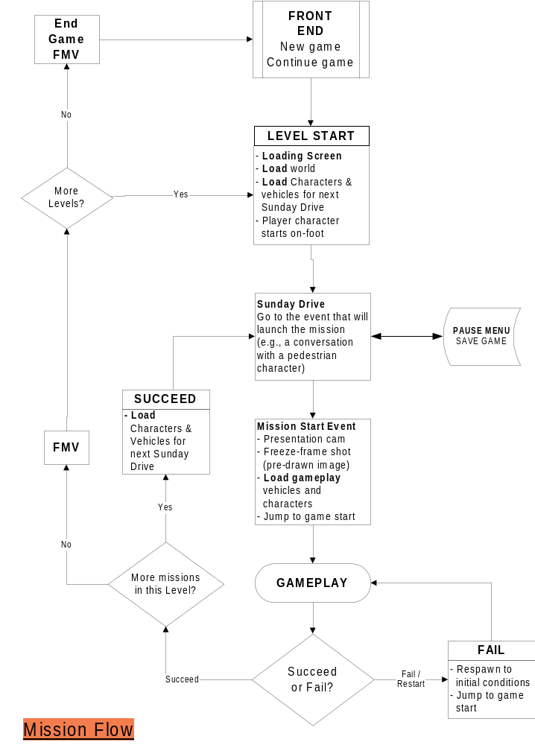

Figure 1

Objectives

Definition: An objective is something the user is asked to do. It is also defined as a discreet game state. In other words, an objective is independent of anything that happened before or will happen after it. (Objectives will appear connected to the user – but an objective definition contains all the information to set up a specified situation).

There are six basic objectives given to the user:
- GO TO [location | vehicle | pedestrian]
- DELIVER N items TO destination
- COLLECT N items
- DRIVE [vehicle] TO destination
  - Drive means you must be in the vehicle when you get to the destination – getting there on foot doesn’t count (GO TO is more general – you can walk or drive)
- FOLLOW vehicle TO destination
- DESTROY N [items | vehicles]

Sunday Drive Objectives

Sunday drive is a series of simple, linear “GO TO”, “DRIVE”, or “PICKUP” objectives. When the final objective is complete the mission-start presentation begins (see presentation document). These three directives can set up the four things that can launch a mission:

- Go to a person on-foot (triggers a conversation)
- Get into a specific car (triggers a driver/passenger conversation)
- Drive a specific car (or your choice of car) to a location (trigger volume)

Example One – Get in to a Car

Description: Get into Homer’s Car
Script:
GO TO VEHICLE Homers_Car //”Homers_Car” is a Maya
// locator
MISSION_START_PRESENTATION Homer // Focus the camera on
// Homer for the
// start-presentation

Example Two – Talk to Two People

Description: Bart (the walking user character) talk to Apu; then Moe
Script:
GO TO CHARACTER Standing_By_Kwik_E-Mart
GO TO CHARACTER Standing_By_Moes
MISSION_START_PRESENTATION Bart // Focus the camera on
// Bart

Notes:
- “Standing_By_Kwik_E-Mart” is a locator in Maya. The script needs to tell the game who is standing there, and what their dialog is.
- Do Sunday Drive missions also need a character [on foot] start location? That is, for when you load a saved game or select/jump to a mission?

Example Three – Get into a Car and Drive to Start Location

Description: Get into Homer’s car, then drive it to the School
Script:
GO TO VEHICLE Homers_Car
DRIVE Homers_Car TO School__L1M3_Start
MISSION_START_PRESENTATION Bart

Gameplay Objectives

A gameplay mission can use any objective. A big difference is that a gameplay mission has only one objective. If we want to link a DELIVER objective to a DESTROY objective, it would actually be two missions.

- GO TO [location | vehicle | pedestrian]
- DELIVER N items [TO | FROM] destination
  - Two types of delivery mission: SEQUENTIAL_ORDER (no choice of order – user gets the items in pre-determined order) or USER_CHOOSES_ORDER
- COLLECT N items
  - Just collect them, but without any delivery component
- DRIVE [vehicle] TO destination
  - Drive means you must be in the vehicle when you get to the destination – getting there on foot doesn’t count (GO TO is more general – you can walk or drive)
- FOLLOW vehicle TO destination
- DESTROY N [items | vehicles]
  - Two types of destruction mission: SEQUENTIAL_ORDER (no choice of order – user destroys the items in pre-determined order) or USER_CHOOSES_ORDER

There are two other additional components to a gameplay mission – failure conditions, and “other attributes” (game times and so on).

Failure Conditions

Failure conditions define what will result in mission failure. There can be more than one for a mission:
- PLAYER VEHICLE DESTROYED
- PLAYER VEHICLE DAMAGED
- PLAYER STRUCK BY VEHICLE WHILE ON FOOT
- AI_VEHICLE vechicle_name ARRIVES FIRST AT destination (i.e., it’s a race)
- TIMER N EXPIRED – N is the # of seconds initially on a game timer (if this condition is omitted, then there is no game clock displayed on the HUD)
- PLAYER GETS OUT OF VEHICLE???
- FAILURE TRIGGER VOLUME – a mission or level can have a trigger volume that causes the mission to fail; this is used for “out of bounds” areas such as large bodies of water
- Note: The game will have a “safety valve” whereby you can skip a mission after failing it N times (designers will tune the number N). This will be recorded in your mission completion status.

Other Attributes

Other things that a gameplay mission must account for:
- Mission setup data that refers to Maya world builder locators:
  - AI Vehicle identities and start locations
  - Player vehicle/on-foot start location
  - Character/Collectible content and locations, e.g.:
    - Apu is standing by the Kwik-E-Mart and talking to him represents collecting a Squishee
- Mission-specific dialog
  - Conversations
  - Mission-specific navigation dialog (e.g., a training line)
- Presentation triggers
  - Camera work and presentation (e.g., you trigger a switch – the game has to show you what you’ve done)
- AI settings:
  - Specify which AI Vehicles will be triggered by proximity?
  - Specify which AI Vehicles are enabled, based on mission conditions
    - e.g., Vehicles 1 through 20 may all be triggered by proximity, but after you’ve destroyed or pickup up an object then Vehicles 1a through 20a are also enabled
    - When you destroy or pickup another object then vehicle 1b through 20 b are also enabled
  - Specify how others AI vehicles are triggered, e.g.:
    - Vehicle 1 activation triggers vehicles 3 & 4
  - Set aggression, strength, and speed of AI vehicle(s) globally for the mission, or based on mission conditions (collectibles and destructibles), e.g.:
ON_COLLECT_2 AI_AGGRESSION_MEDIUM
ON_COLLECT_3 AI_AGGRESSION_HIGH
ON_COLLECT_2 AI_SPEED_HIGH
- TIMER - are there any things that will add time back onto the timer?
- Bonus criteria and definition. The two criteria are time remaining and your damage level, one of which will be used for each mission, e.g:
GOLD TIME_LEFT 10
SILVER TIME_LEFT 5
or
GOLD VEHICLE_CONDITION 100%
SILVER VEHICLE_CONDITION 50%
- VEHICLE REQUIREMENT???

Gameplay Example Objectives
The following gameplay script examples are taken from our first ten gameplay missions:

- Level 1: FOLLOW Marge TO Kwik-E-Mart
- Level 2: DELIVER 1 item TO destination
- Level 3 GO TO destination (race - failure condition is other vehicle getting there first)
- Level 4: DRIVE vehicle TO destination
- Level 5: DESTROY vehicle (start on-foot)
- Level 6: GO TO destination
- Level 7: DESTROY 4 items
- Level 8: Follow AI to destination
- Level 9: DELIVER 1 item TO destination

Real-time AI Scripting

There are a small number of things that the mission-scripter needs to be able to control in real-time, during gameplay:
- Activating certain AI cars on trigger volumes, or upon the activation of another specific AI car (which is activated by proximity)
- Activating or de-activating an animated bounding volume (i.e., turn on the ferry or a drawbridge, open/close a barrier, etc.)
  - Including dynamic physics-object bvs, such as a scripted vehicle
- Add time to the game-timer?
  - Do we need this? If so, what’s the associated presentation?
- Hide from chase AI?
- Pause/re-enable chase AI? (i.e., they come to a stop until you re-activate them at another script?)

Missions

Goals
- Gentle learning curve – the first missions should teach the user about the game
- Variety – don’t get stuck in a rut of one kind of missions
  - Use collectible types (e.g., conversations, world interaction, etc.) to mask the simplicity and repetitiveness of mission types
  - Utilize out of the car gameplay (e.g., changing vehicles)
- Chase AI (i.e., vehicles chasing the user) is the core of the gameplay
  - There are more interesting variations and AI tactics/defenses with the chase AI than any other mode

Mission Flow
A mission can be described as having two components:

- Sunday Drive. This component describes what the user does to launch a “gameplay mission start” event. The things you can be asked to in this context are:
  - Go to a person on-foot (triggers a conversation)
  - Get into a specific car (triggers a driver/passenger conversation)
  - Pick up a person? (triggers a passenger/passenger conversation)
  - Drive a specific car to a location (trigger volume)
  - There can be more than one of these objectives in a Sunday Drive sequence
  - If there is more than one objective, then only the final one will launch the “gameplay mission start” event
- Gameplay. Describes the purpose, the gameplay, expected length and difficulty.
  - Note: Duration is a particularly important number. It tells you how long it should take a typical gamer to get through this mission, including the expected number retries. This number must be measured against focus tests, with two goals in mind:
    - Don’t want the game to be too short (e.g., if missions are too easy and don’t require retries)
    - Don’t want the missions to be too frustrating

The flow of missions throughout a level is illustrated in Figure 1 – Mission Flow.

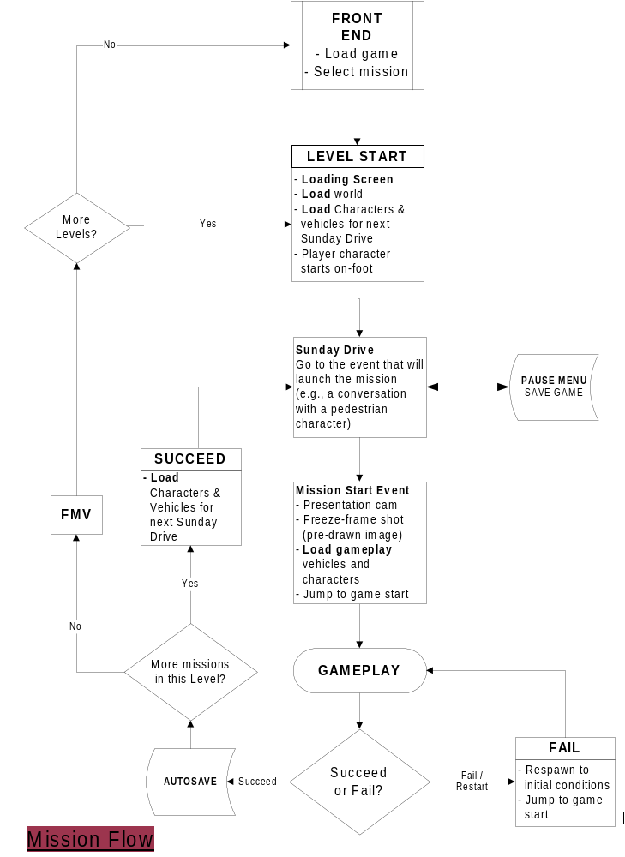

Figure 1

Level Order

Level 1 – Evergreen Terrace
Level 2 – Squidport
Level 3 – Downtown
Level 4 – Power Plant
Level 5 – Squidport
Level 6 – Downtown
Level 7 – Power Plant
Level 8 – Evergreen Terrace
Bonus Level – Halloween

Level Direction

The missions in levels 1 to 4 will generally run clockwise around the neighborhoods. The missions in levels 5to 8 will generally run counter-clockwise.

Level 1 - Evergreen Terrace

Training Missions 1 through 9

The purpose of these levels is to teach the user about basic game elements:
- Driving:
  - How to drive the car
  - Escape AI vehicles:
    - Follow an AI vehicle
    - Destroy an AI vehicle
  - Navigate to a place in the world (use the map)
  - IN-CAR Collection – break an object
  - Chase AI vehicles:
    - Using driving techniques (swerve through traffic)
    - Using world counter-measures (jump escape)
    - Using vehicle countermeasures
  - Advanced driving technique 1 – smooth accelerations
- On-foot:
  - Interact with a world object (push a button)
  - Initiate conversations
  - Get in/out of vehicles
  - Change vehicles mid-mission
  - Collect objects by talking to someone

L1M1 CHASE – Drive the Car

Sunday Drive – How you get to the place that launches a gameplay mission.
Purpose | Learn how to:  - Walk  - Run  - Get into a vehicle  - Initiate a mission start
Description | - Start the game on foot near a vehicle  - User walks up to the vehicle, and gets in  - Driver/passenger conversation launches mission
Length | 60 seconds (with user run/walk experimentation)

Gameplay – Describes a gameplay mission
Purpose | Learn how to drive the car
Description | Follow a vehicle on an easy, casual route
Length | 90 seconds
Duration | 3 minutes (with 1 retry)
Challenge Level | Trivial – success depends only on controlling the vehicle

L1M2 COLLECTION ON FOOT – Chase AI, Vehicle Damage

Sunday Drive
Purpose | - Learn how to navigate using the map  - Learn how to get out of a vehicle
Description | - Drive to a pedestrian character  - Get out of the car and initiate a conversation – this launches the mission
Length | 60 seconds

Gameplay
Purpose | Introduce chase AI and vehicle damage system
Description | Drive to a location, collect an object, and drive to another location to deliver it  - Collect an object from a pedestrian  - Light chase AI on the way  - Driving-evasion countermeasure (passenger suggests it?)  - Jump countermeasure on way back (i.e., jump to escape)  - User-vehicle destruction ends mission
Length | 120 seconds
Duration | 4.5 minutes (one retry, 30 seconds collecting object)
Challenge Level | Easy – avoid being destroyed

L1M3 CHASE – High Speed Starts

Sunday Drive
Purpose | Learn how to interact with a world object
Description | - Put the vehicle that launches the next mission behind a barrier of some kind; the user has to open by pressing a button?  - Mission starts by driving to a location
Length | 60 seconds

Gameplay
Purpose | Advanced driving 1 – the smooth/fast start
Description | - A drag race – need a smooth start to win (don’t spin the tires too much – need a dialog hint)  - Learn how to avoid traffic  - Keep them on a fairly straight road – don’t want to add the challenge of making turns in a race yet
Length | 30 seconds
Duration | 90 seconds (2 retries)
Challenge Level | Medium – learn the smooth start, and avoid AI traffic while driving at high speed

L1M4 COLLECTION ON FOOT – Vehicle Countermeasures

Sunday Drive
Purpose | - Switch to an oil-slick vehicle  - Learn about in-car mission starts
Description | - Incorporate world interaction – need to press a switch to get access to the car  - Drive it to the mission-start location
Length | 90 seconds

Gameplay
Purpose | Learn about vehicle countermeasures
Description | - Give the user a light, fragile oil-slick vehicle  - Dialog tips on how to use it  - The objective is two collect two objects – use them to create two 90 second chase-AI segments  - Encourage them to switch to a tough vehicle with speed burst (i.e., make the second part of the mission very difficult unless they have it, and provide a dialog hint)  - User vehicle-destruction ends the mission
Length | 3 minutes (2 90 second segments)
Duration | 10 minutes (two retries, 60 seconds switching vehicles)
Challenge Level | Medium – survive an AI assault – easy if you’ve chosen the right vehicle

L1M5 CHASE & DESTROY– Destroy an AI Vehicle

Sunday Drive
Purpose | Get user out of the car
Description | - Mission start is triggered by conversation with a pedestrian
Length | 60 seconds

Gameplay
Purpose | - Learn how to disable/destroy an AI vehicle  - Learn importance of vehicle choice  - Learn about starting a mission on-foot
Description | - Escape vehicle is a little slower than your car, but has a head start (i.e., you start on foot)  - Player has choice of two cars – heavy and slow (but with speed burst), fast and fragile  - Heavy and slow is the best choice – so put it a couple meters further from the player start  - Player starts on foot, and runs to one of the two cars, both of which are nearby
Length | 90 seconds
Duration | 5 minutes (2.5 retries, 30 seconds out of car)
Challenge Level | Easy – Medium; choose the right car and it’s not too hard

L1M6 COLLECTION ON FOOT – High Speed Cornering

Sunday Drive
Purpose | Introduce walking/running skill element without time pressure
Description | - Drive/walk to the vehicle that will launch the next mission  - Make them walk on top of a high, narrow walkway that they can fall off of – this is training for later in the game where they’ll do things this while under time pressure  - Passenger/driver conversation triggers mission start
Length | 90 seconds

Gameplay
Purpose | - Advanced driving techniques 2 – high speed cornering  - Avoiding a scripted collision volume (with infinite mass)
Description | - The user has a fast that’s good at powerslides  - Drive to high speed and hit a wide-open 90-degree corner  - Dialog tip on how to do power-slide?  - To finish the mission you have to use a shortcut that incorporates an animated physics object or barrier
Length | 60 seconds
Duration | 3 minutes (three retries)
Challenge Level | Medium

L1M7 COLLECTION IN CAR – Destroy Objects

Sunday Drive
Purpose
Description | - Get a particular vehicle  - Mission starts by driving to a location
Length | 90 seconds

Gameplay
Purpose | - Learn about breaking objects  - Learn about navigation to choose the best path  - Learn about AI aggressiveness in response to your actions  - Learn how to do “Rockfords” (reverse powerslides)
Description | - You need to destroy 4 objects in the world  - You start pointed away from the first object, and an audio-cue tells you to “do a Rockford”  - Some items to break are in a dead-end, to encourage more use of this technique  - Each time you destroy one, the AI aggressiveness and density goes up  - Therefore the best order to hit them is not choosing closest to your start location – you choose the order so that the distance between destructible 3 and 4 is minimized  - User-vehicle destruction ends mission
Length | 2.5 minutes
Duration | 7.5 minutes (3 retries)
Challenge Level | Medium – Hard (AI will be very hard to evade if you don’t choose a good order to hit the destructibles)

L1M8 CHASE – High Speed Chase

Sunday Drive
Purpose | Acquire a fast vehicle
Description | Mission starts with player/driver conversation
Length | 60 seconds

Gameplay
Purpose | - Keep up with a high-speed escape-AI vehicle  - Perform high-speed powerslides on dirt (“Rally mode”)  - Use countermeasure to keep a small number of AI vehicles off your tail
Description | - The AI vehicle is as fast as yours  - Get too far away and the mission fails (dialog cue? HUD?)
Length | 2 minutes
Duration | 6 minutes (3-4 retries)
Challenge Level | Hard (requires error-free driving over a long distance)

L1M9 BOSS 1

Sunday Drive
Purpose | - Provide the user with a choice of vehicles (fast or control)
Description | Mission starts by driving to a location
Length | 1 minute

Gameplay
Purpose | Learn how to Lure the Truckasaurus
Description | - Collect objects on-foot  - Chase-AI presence  - The last item is being guarded by the Truckasaurus  - See Boss 1 in section ??? for more detail
Length | 3 minutes
Duration | 9 minutes (3 retries)
Challenge Level | Medium-Hard

Game Clock for Level 1

65 minutes total gameplay time for an average gamer for this entire level. A perfect run (no errors) would take 31.5 minutes.

Level 2 – Squidport

L2M1 COLLECTION IN CAR – Destroy the Shipment

Sunday Drive
Purpose | Demonstrate the importance of vehicle choice
Description | - The user chooses between a fast vehicle and a tough one  - Drive to the starting line
Length | 1 minute

Gameplay
Purpose | - Introduce the user to more aggressive AI chase vehicles
Description | - Drive to the docks and destroy some objects on the ship(s)  - AI pressure intensifies the closer you get  - Some shortcuts let you avoid AI pressure  - Vehicle destruction ends mission?
Length | 2 minutes
Duration | 8 minutes (4 retries)
Challenge Level | Medium – Difficult

L2M2 CHASE & DESTROY – Destroy a Group of Vehicles

Sunday Drive
Purpose | Introduce “goose chase” mission introduction style – talk to two different people
Description | Talk to two pedestrians to launch the mission
Length | 60 seconds

Gameplay
Purpose | - Introduce new gameplay element of destroying a number or roaming AI vehicles (i.e., they are on looping paths)
Description | - Start on-foot  - Choose one of two vehicles (control or fast) during mission (i.e., under time pressure)  - Use the map to find and destroy vehicles  - Utilize an interactive world component (e.g., user having to start a ferry or rotating bridge)
Length | 2.5 minutes
Duration | 9 minutes (3 retries, 30 seconds choosing vehicles)
Challenge Level | Medium – track down the cars

L2M3 COLLECTION ON FOOT – The Goose Chase

Sunday Drive
Purpose
Description | Have the initial conversation that launches the chase
Length | 1 minute

Gameplay
Purpose | Introduce the collectible mission style where the user has no choice of collection-order
Description | - Send the user on a goose-chase around the level, talking to one character after another or collecting items  - Make them use world interaction to succeed (e.g., some collectible or a faster car is behind a door of some kinf)
Length | 3 minutes
Duration | 9 minutes (3 retries)
Challenge Level | Medium – Hard; requires efficient use of shortcuts

L2M4 CHASE – A Race

Sunday Drive
Purpose
Description | Get to on-foot start location
Length | 1 minute

Gameplay
Purpose | Introduce a real race, with a light AI chase presence
Description | - A race around the neighborhood (be careful not to require AI cars to drive through complicated shortcuts or jumps, as they probably won’t be able to)  - Include light AI chase presence  - Note that races are A-B, not circuits – we have no logic or HUD for counting laps and such
Length | 3 minutes
Duration | 9 minutes (3 retries)
Challenge Level | Medium – Hard; should require use of at least some shortcuts (dialog hint needed)

L2M5 COLLECTION ON FOOT – Drive on a moving BV

Sunday Drive
Purpose | Get the user into a fragile car
Description
Length | 1 minute

Gameplay
Purpose | - Learn to drive on an animated BV  - Learn to to change cars to avoid a vehicle-destroyed damage state
Description | - Collect some kind of objects – your choice of order  - With each one the AI becomes more and more intense  - The last one is on a ship or some other kind of BV that is moving as you are driving on it  - It is very very difficult to survive the AI assault in one car  - Other cars are placed in fairly obvious locations for you to see  - You have to plan your switch so that you aren’t hit while out of the car
Length | 3.5 minutes
Duration | 10.5 minutes (3 retries)
Challenge Level | Hard

L2M6 COLLECTION ON FOOT

Sunday Drive
Purpose
Description | Star with a conversation, with the person who wants you to get some objects
Length | 1 minute

Gameplay
Purpose | Introduce the collectible mission style where the user has to deliver the objects to someone
Description | - User-choice of order  - More objects than you need – you have to choose the right ones to do the mission in time  - Deliver them back to the person who launched the mission
Length | 3 minutes
Duration | 9 minutes (3 retries)
Challenge Level | Medium – Hard; requires efficient use of shortcuts

L2M7 CHASE – The Getaway

Sunday Drive
Purpose | Get the user into a fast & fragile vehicle
Description
Length | 1 minute

Gameplay
Purpose | - Keep up with a high-speed escape-AI vehicle  - Perform high-speed powerslides on dirt (“Rally mode”)  - Use countermeasure to keep a small number of AI vehicles off your tail
Description | - The AI vehicle is as fast as yours  - Get too far away and the mission fails (dialog cue? HUD?)
Length | 3 minutes
Duration | 9 minutes (3-4 retries)
Challenge Level | Hard (requires error-free driving over a long distance)

L2M8 BOSS 2

Sunday Drive
Purpose | Get the user out of the car
Description | Start the mission with an on-foot conversation
Length | 1 minute

Gameplay
Purpose
Description | - Run to your car  - Lead the boss through a maze, into a trap  - Chase AI cars try to ram you head-on  - See Boss 2 in section ??? for more detail
Length | 3 minutes
Duration | 9 minutes
Challenge Level | Medium – Hard

Game Clock for Level 2

80.5 minutes for a typical gamer, 31 minutes for a perfect run.

Level 3 – Downtown

L3M1 COLLECTION ON FOOT – The Runaround

Sunday Drive
Purpose | Start the mission on-foot with a conversation?
Description
Length | 1 minute

Gameplay
Purpose | A “goose chase” style mission to show off the new level
Description | - Send the user on a goose-chase around the level, talking to one character after another or collecting items  - Make them use world interaction to succeed  - Moderate Chase AI pressure
Length | 4 minutes
Duration | 12 minutes (3 retries)
Challenge Level | Medium – Hard

L3M2 CHASE – Follow the Leader

Sunday Drive
Purpose
Description
Length | 1 minute

Gameplay
Purpose | Learn to drive through trickier parts of the map (the multiplayer area)
Description | - Choose a car (control or speed)  - Follow a car through the multiplayer areas of the map (i.e., they are trying to lose you)  - Light chase AI pressure
Length | 3 minutes
Duration | 9 minutes (3 retries)
Challenge Level | Medium-Hard

L3M3 CHASE & DESTROY – Destroy Vehicles

Sunday Drive
Purpose
Description
Length

Gameplay
Purpose
Description | - Start on-foot  - Choose one of two vehicles (control or strong)  - Use the map to find and destroy vehicles  - Utilize an interactive world component  - Light AI pressure
Length | 3 minutes
Duration | 10 minutes (3 retries, 30 seconds choosing vehicles)
Challenge Level | Medium - Hard

L3M4 COLLECTION ON FOOT – Lost and Found

Sunday Drive
Purpose
Description
Length | 1 minute

Gameplay
Purpose | A trivia-style mission
Description | - Find and Talk to many different characters  - They don’t show up on the map  - They each give you a clue how to find the next one (e.g., you’ll need to talk to the Mayor – you have to know he’d be at City Hall)  - Light or no AI pressure – AI could be a frustrating element in this kind of mission
Length | 5 minutes
Duration | 10 minutes (2 retries)
Challenge Level | Easy – Medium

L3M5 CHASE – A Race

Sunday Drive
Purpose
Description
Length | 1 minute

Gameplay
Purpose | A race that starts in a tricky H2H zone, and ends up across town
Description | - Choose a vehicle (fast, control, or strength)  - Race from ??? to ???  - Moderate Chase-AI presence
Length | 2 minutes
Duration | 7 minutes (3 retries, 1 minute out of car)
Challenge Level | Hard

L3M6 COLLECTION IN CAR – Destroy objects

Sunday Drive
Purpose
Description
Length

Gameplay
Purpose | Wreck some stuff for a change of pace
Description | - Destroy objects  - User choice of order  - Chase AI gets more intense the more you destroy (use this to make the order you destroy objects significant – i.e., your strategy is to minimize the distance between later objects)
Length | 4 minutes
Duration | 12 minutes (3 retries)
Challenge Level | Medium

L3M7 CHASE – Chase a Vehicle

Sunday Drive
Purpose
Description
Length | 1 minute

Gameplay
Purpose | Learn to drive through trickier parts of the map (the multiplayer area)
Description | - Choose a car (control, speed, or strength)  - Follow a car around Downtown (i.e., they are trying to lose you)  - Heavy chase AI pressure
Length | 3 minutes
Duration | 12 minutes (4 retries)
Challenge Level | Hard

L3M8 BOSS 3

Sunday Drive
Purpose | Get the user out of their car
Description
Length | 1 minute

Gameplay
Purpose
Description | - Run to your car  - It’s pointed towards the boss – you have to do a quick 180  - Capture the boss in a “cage”  - See Boss 3 in section ??? for more detail
Length | 1.5 minutes
Duration | 5 minutes (3-4 retries)
Challenge Level | Hard

Level 4 – Power Plant

L4M1 COLLECTION ON FOOT – Going Inside

Sunday Drive
Purpose
Description | 1 minute
Length

Gameplay
Purpose | Introduce the player to an indoor play area
Description | - Collect objects from 2 different indoor areas  - Chase-AI presence between the two  - An alternate car you can switch into  - The user has to operate elevators or other interactive elements in both areas
Length | 4 minutes
Duration | 10 minutes (2.5 retries)
Challenge Level | Medium

L4M2 COLLECTION IN CAR – The Trains and the Plant

Sunday Drive
Purpose
Description
Length | 1 minute

Gameplay
Purpose | Avoid animated physics objects, introduce Power Plant shortcut
Description | - You have to destroy a number of objects spread around the train yards  - And destroy some in another location that requires you to go straight across the Power Plant
Length | 3 minutes
Duration | 10.5 minutes (3-4 retries)
Challenge Level | Medium-Hard

L4M3 COLLECTION ON FOOT – The Key Hunt

Sunday Drive
Purpose
Description
Length

Gameplay
Purpose | Introduce a “puzzle” key-hunt kind of mission
Description | - Collect objects  - You have to find a character based on Simpsons knowledge, who’s in a location you’ve been shown in an earlier mission (e.g., Burns’ office)  - You also have to use an elevator or activate a switch to get to what you need (specifics TBD, including how we will clue-in the user to what they need to do)  - Chase-AI presence in a driving segment
Length | 4 minutes
Duration | 10 minutes (2.5 retries)
Challenge Level | Medium

L4M4 CHASE & DESTROY – Destroy the Vehicles

Sunday Drive
Purpose
Description
Length

Gameplay
Purpose | The one chase mission on this level, for variety
Description | - Destroy several vehicles  - The vehicles are on paths in the road-based parts of the level, in-between the big indoor structures  - Question – can one of them be inside the stadium? Can we make part of the stadium ground out of road pieces?
Length | 4 minutes
Duration | 12 minutes (3 retries)
Challenge Level | Medium-Hard

L4M5 COLLECTION ON FOOT – Going Shopping

Sunday Drive
Purpose
Description
Length | 1 minute

Gameplay
Purpose | Learn how to use elevation to your advantage when on-foot
Description | - Collect items in the mall, using an elevator to go up and down  - There is a faster way down – an open ledge you can walk off (i.e., your character will fall to the ground)  - Needs an audio hint?  - Chase-AI pressure on the way to/from the Mall (more on the end part)
Length | 4 minutes
Duration | 12 minutes (3 retries)
Challenge Level | Medium – Hard

L4M6 COLLECTION IN CAR – 64 Bottles of…

Sunday Drive
Purpose
Description
Length | 1 minutes

Gameplay
Purpose
Description | - Destroy kegs of beer at the brewery  - Need to get out of car to open a barrier to an area  - On-foot you have to also take an elevator, to get to the switch (the elevator is always animating, so that it’s a visual cue)  - Chase-AI to and from the brewery
Length | 4 minutes
Duration | 10 minutes (2.5 retries)
Challenge Level | Medium

L4M7 COLLECTION ON FOOT – The Grand Tour

Sunday Drive
Purpose
Description
Length | 1 minute

Gameplay
Purpose | - Collect an item from every major indoor area in the level  - Learn the best route
Description | - Use elevators, shortcuts, and animated physics objects for a Grand Tour of this level
Length | 5 minutes
Duration | 15 minutes (3 retries)
Challenge Level | Medium-Hard

L4M8 BOSS 4

Sunday Drive
Purpose
Description
Length | 1 minute

Gameplay
Purpose
Description | - Drive to the stadium as Homer  - Chase-AI pressure  - Collect the “motion capture suit” object  - Control the Tuckasaurus  - See Boss 4 in section ??? for more detail
Length | 2 minutes
Duration | 8 minutes (4 retries)
Challenge Level | Hard

Level 5 – Squidport

L5M1 COLLECTION ON FOOT – A New Place

Sunday Drive
Purpose | Acquire a vehicle
Description | - Find a vehicle  - Get to the wharf and either talk to a pedestrian or a driver to start the mission
Length | 1 minute

Gameplay
Purpose | Get over the disappointment of “no more new levels:  - Go to an unlocked area that was not previously available, such as “Sir Putt a Lots” mini-golf course.  - You have to operate a button to get in (i.e., go to an automatic ticket booth and pay?)  - See nighttime for the first time?  - Remember to send the user counter-clockwise (i.e., up the San Fran-like hill)
Description | - Go to the “new” destination  - Collect an object by talking to a pedestrian (on foot)  - Deliver the object somewhere (to the dam?)  - AI is light on the first leg, very heavy on the second (after the object’s been pickup up)  - Hide a replacement vehicle (on top of the parkade?)
Length | 3 minutes
Duration | 11 minutes (3 retries, 2 minutes on-foot)
Challenge Level | Medium-Hard

L5M2 CHASE – A Chase

Sunday Drive
Purpose | Get the user on-foot
Description
Length | 1 minute

Gameplay
Purpose | Keep up on a convoluted car chase
Description | - Choose a vehicle (speed or control)  - Keep up with a vehicle as it tries to lose you in the docks  - End up near Krustylu
Length | 4 minutes
Duration | 10 minutes (2.5 retries)
Challenge Level | Medium

L5M3 COLLECTION ON FOOT – Find the People

Sunday Drive
Purpose
Description | - Choose your vehicle, control or strong  - take it to the launch point (a pedestrian?)
Length | 1 minute

Gameplay
Purpose | Find the best route [counter-clockwise] around the city to meet 4 pedestrians (and collect an object)
Description | - The four are spread around the city  - You have to find the best routes (shortcuts, and deciding which way to go on the last one – it will be nearly halfway around the city, but one way’s faster than the other)  - AI vehicles harass you, getting worse the more you collect  - At least one replacement vehicle is available on the way
Length | 5 minutes
Duration | 15 minutes (3 retries)
Challenge Level | Medium-Hard

L5M4 CHASE & DESTROY – Destroy Vehicles

Sunday Drive
Purpose | Get the user on-foot
Description | Talk to a pedestrian
Length | 1 minute

Gameplay
Purpose
Description | - Start on-foot  - Choose one of two or three vehicles (control, heavy, or speed) during mission  - Use the map to find and destroy vehicles  - Utilize an interactive world component (e.g., maybe the best vehicle, a very strong one, is behind a door or barrier of some kind?)  - Light AI-chase presence
Length | 3 minutes
Duration | 10 minutes (3 retries, 1 minute on foot)
Challenge Level | Medium – Hard

L5M5 COLLECTION IN CAR – Destroy Objects

Sunday Drive
Purpose | Acquire a vehicle
Description
Length | 1 minute

Gameplay
Purpose | Wreck some stuff for a change of pace
Description | - Destroy objects  - User choice of order  - Chase AI gets more intense the more you destroy (use this to make the order you destroy objects significant – i.e., your strategy is to minimize the distance between later objects)
Length | 3 minutes
Duration | 9 minutes (3 retries)
Challenge Level | Medium – Find the best path, avoid chase AI

L5M6 CHASE – Race Up the Hill

Sunday Drive
Purpose
Description
Length | 1 minute

Gameplay
Purpose | A “hill climbing” race or chase (either up the San Fran city hill, or the Rally route)
Description | - Choose a vehicle (fast or control)  - Race from the wharf or the docks to the dam  - Light Chase-AI presence
Length | 2 minutes
Duration | 7 minutes (3 retries, 1 minute out of car)
Challenge Level | Hard

L5M7 COLLECTION ON FOOT – Another New Place

Sunday Drive
Purpose
Description | Choose a car (heavy or control)
Length | 1 minute

Gameplay
Purpose | Collection mission that takes you to the other new place (i.e., that wasn’t available the first time you player Squidport)
Description | - Drive to ?  - Talk to a pedestrian  - Drve to ? with Chase-AI presence  - Talk to a pedestrian  - Get into another vehicle  - Get to a destination under AI pressure
Length | 5 minutes
Duration | 15 minutes
Challenge Level | Hard

L5M8 BOSS 5

Sunday Drive
Purpose
Description
Length | 1 minute

Gameplay
Purpose | Outsmart the Truckasaurus
Description | - Collect objects on-foot  - Chase-AI presence  - The last item is being guarded by the Truckasaurus  - See Boss 5 in section ??? for more detail
Length | 3 minutes
Duration | 9 minutes (3 retries)
Challenge Level | Medium-Hard

Game Clock for Level 5

85 minutes for a typical gamer, 35 minutes for a perfect run.

Level 6 – Downtown

L6M1 CHASE – A Race

Sunday Drive
Purpose
Description
Length

Gameplay
Purpose
Description | - Choose a vehicle (speed or control)  - Race a vehicle to a destination  - Chase-AI vehicles pressure you  - A shortcut lets you make up time the AI chasers cost you  - Alternate vehicle on the route?
Length | 3 minutes
Duration | 9 minutes (3 retries)
Challenge Level | Medium-Hard

L6M2 COLLECTION ON FOOT – A New Place

Sunday Drive
Purpose
Description | On-foot conversation starts mission
Length | 1 minute

Gameplay
Purpose | Show a new part of the level
Description | - Go to an unlocked area that was not previously available  - Collect an object by talking to a pedestrian (on foot)  - Get back to your start location/character  - AI is light on the first leg, very heavy on the second (after the object’s been pickup up)  - Hide a replacement vehicle on the return trip
Length | 3 minutes
Duration | 10 minutes (3 retries)
Challenge Level | Medium-Hard

L6M3 CHASE & DESTROY – 3 Bad Guys

Sunday Drive
Purpose
Description
Length | 1 minute

Gameplay
Purpose
Description | - Find and destroy three vehicles  - One in each part of town  - Chase AI pressure increases with each one you destroy
Length | 5 minutes
Duration | 15 minutes (3 retries)
Challenge Level | Medium-Hard

L6M4 COLLECTION IN CAR – Destroy Objects

Sunday Drive
Purpose
Description
Length | 1 minute

Gameplay
Purpose | Wreck some stuff for a change of pace
Description | - Destroy objects  - User choice of order  - There are more on the map than you need to destroy, but you don’t have time to get to all of them – choose which ones to destroy  - Chase AI gets more intense the more you destroy
Length | 3 minutes
Duration | 9 minutes (3 retries)
Challenge Level | Medium – Hard

L6M5 CHASE – A Chase

Sunday Drive
Purpose
Description
Length

Gameplay
Purpose | A convoluted chase around Downtown
Description | - Choose a vehicle (speed or control)  - Chase a vehicle on a convoluted, high-speed path
Length | 5 minutes
Duration | 10 minutes (2 retries)
Challenge Level | Mdium

L6M6 COLLECTION ON FOOT – Another New Place

Sunday Drive
Purpose
Description
Length

Gameplay
Purpose | Show a new part of the level
Description | - Go to an unlocked area that was not previously available  - Collect an object by talking to a pedestrian (on foot)  - Visit other areas for more collectibles (user choice of order)  - Get back to your start location/character  - AI more intense with each pickup  - Hide a replacement vehicle on the return trip
Length | 4 minutes
Duration | 12 minutes (3 retries)
Challenge Level | Medium-Hard

L6M7 CHASE & DESTROY – A Tough Vehicle

Sunday Drive
Purpose
Description | Give the user a choice of 3 vehicles
Length | 1 minute

Gameplay
Purpose | Chase and destroy a tough, fast vehicle
Description | - Follow and destroy a fast, tough vehicle  - Once you know his route, you can use shortcuts to get ahead of him and then ram him head-on  - Chase AI pressure
Length | 3 minutes
Duration | 12 minutes (4 retries)
Challenge Level | Hard

L6M8 BOSS 6

Sunday Drive
Purpose
Description
Length | 1 minute

Gameplay
Purpose | - Cage the Truckasaurus  - See Boss 6 in section ??? for more detail
Description | 2 minutes
Length | 6 minutes (3 retries)
Duration | Medium-Hard
Challenge Level

Level 7 – Power Plant

L7M1 COLLECTION ON FOOT – A New Place

Sunday Drive
Purpose
Description
Length | 1 minute

Gameplay
Purpose | Show the player to new indoor play area, that was locked the first time through this level
Description | - Collect objects from 2 different indoor areas  - Chase-AI presence between the two  - An alternate car you can switch into  - The user has to operate elevators or unlock a door to gain access to an area  - Maybe use the idea of a locked door, with a button on an overhead walkway … a nearby walking elevator is the cue that you need to go up there
Length | 4 minutes
Duration | 10 minutes (2.5 retries)
Challenge Level | Medium

L7M2 COLLECTION IN CAR – Shopping

Sunday Drive
Purpose
Description
Length | 1 minute

Gameplay
Purpose
Description | - Destroy objects in the Mall  - Chase-AI to and from the brewery (i.e., you start and finish on the other side of the neighborhood)
Length | 4 minutes
Duration | 10 minutes (2.5 retries)
Challenge Level | Medium

L7M3 COLLECTION ON FOOT – Another New Place

Sunday Drive
Purpose
Description
Length

Gameplay
Purpose | - Show the player another new play area that was previously locked  - Utilize Simpson knowledge
Description | - Collect objects  - Chase-AI presence  - An alternate car  - The user has to find an object based on Simpsons knowledge (e.g., knowing that Ned would be at the Mall by his store)
Length | 4 minutes
Duration | 10 minutes (2.5 retries)
Challenge Level | Medium

L7M4 CHASE & DESTROY – Destroy Vehicles

Sunday Drive
Purpose
Description
Length | 1 minute

Gameplay
Purpose
Description | - Destroy five vehicles  - One in between each of the major structures  - One inside the stadium  - AI chase vehicles take runs at you on the road
Length | 5 minutes
Duration | 15 minutes (3 retries)
Challenge Level | Medium-Hard

L7M5 COLLECTION ON FOOT – Get the Goods

Sunday Drive
Purpose
Description
Length | 1 minute

Gameplay
Purpose
Description | - Collect an object from each major structure  - Chase AI in between them  - You can use the Power Plant shortcut to your advantage
Length | 5 minutes
Duration | 12.5 minutes (2-3 retries)
Challenge Level | Medium

L7M6 COLLECTION IN CAR – Stadium Loop

Sunday Drive
Purpose
Description
Length | 1 minute

Gameplay
Purpose
Description | - Destroy some objects  - Include a high-speed loop around the interior of the stadium  - Include trips to other tricky areas like the brewery and the train yards
Length | 4 minutes
Duration | 12 minutes (3 retries)
Challenge Level | Medium-Hard

L7M7 COLLECTION ON FOOT – Find the …

Sunday Drive
Purpose
Description
Length | 1 minute

Gameplay
Purpose
Description
Length
Duration
Challenge Level

L7M8 BOSS 7

Sunday Drive
Purpose
Description
Length | 1 minute

Gameplay
Purpose
Description | - Run to your car  - Lead the boss through a maze, into a trap  - Chase AI cars try to ram you head-on  - See Boss 7 in section ??? for more detail
Length | 2 minutes
Duration | 8 minutes (4 retries)
Challenge Level | Hard

Level 8 – Evergreen Terrace

L8M1 CHASE – A Race

Sunday Drive
Purpose | Get to the starting line
Description | - Choose a vehicle  - Go to the start  - Generic AI chase vehicles harassing you during the race
Length | 1 minute

Gameplay
Purpose | Start the level off with a race
Description | Win a race around Evergreen Terrace
Length | 4 minutes
Duration | 14 minutes (3.5 retries)
Challenge Level | Difficult

L8M2 COLLECTION IN CAR– Beat ‘em Up

Sunday Drive
Purpose | Get to start location
Description | Conversation with a pedestrian
Length | 1 minute

Gameplay
Purpose | Destroy a number or roaming AI vehicles (player needs some catharsis after a race!)
Description | - Start on-foot  - Choose one of two vehicles (strong or fast) during mission  - Use the map to find and destroy vehicles
Length | 3 minutes
Duration | 12 minutes (4 retries)
Challenge Level | Difficult – hard to catch them with the tough car, hard to destroy them with the fast one

L8M3 COLLECTION ON FOOT– Someplace New

Sunday Drive
Purpose
Description | Choose vehicle – control or speed
Length | 1 minute

Gameplay
Purpose | - Go to an unlocked area that was not previously available
Description | - Go to the “new” destination  - Collect an object by talking to a pedestrian (on foot)  - Deliver the object somewhere  - AI is light on the first leg, very heavy on the second (after the object’s been pickup up)  - Hide a replacement vehicle (on top of the parkade?)
Length | 3 minutes
Duration | 11 minutes (3 retries, 2 minutes on-foot)
Challenge Level | Medium-Hard

L8M4 BOSS 8 – The Final Boss ???

Sunday Drive
Purpose
Description | Get the player to desired on-foot starting location
Length | 1 minute

Gameplay
Purpose
Description | - Drive to the stadium  - Chase-AI pressure  - Kill the Truckasaurus  - See Boss 8 in section ??? for more detail
Length | 3 minutes
Duration | 12 minutes (4 retries)
Challenge Level | Hard

L8M5 COLLECTION ON FOOT – Get the Goods

Sunday Drive
Purpose
Description | Talk to the pedestrian (to whom you will eventually deliver objects) to start the mission
Length | 1 minute

Gameplay
Purpose | Object delivery, with chase AI
Description | - Collect N objects  - Deliver them to someone  - User choice of path  - AI gets harder and more numerous with each pickup  - Vehicle destruction ends mission  - An alternate vehicle is hidden on the mission somewhere
Length | 3 minutes
Duration | 9 minutes (3 retries)
Challenge Level | Medium – Hard; find the best path and/or an alternate vehicle (or maybe you require the alternate vehicle to survive – in which case we’d need a dialog hint)

L8M6 CHASE & DESTROY – Catch the Race Vehicle

Sunday Drive
Purpose
Description | Get a vehicle to the starting line
Length | 1 minute

Gameplay
Purpose | Catch up to this amazing new vehicle (Car built for Homer?)
Description | - Chase the car through the city  - Destroy it  - AI chase vehicle harass you during the chase
Length | 4 minutes
Duration | 12 minutes (3 retries)
Challenge Level | Hard

L8M7 CHASE – The Race

Sunday Drive
Purpose | - Acquire a specific vehicle (the Ferrini)?  - Choice of vehicle?
Description | - Get into the vehicle we want you to race with  - Go to the starting line
Length | 1 minute

Gameplay
Purpose | Acquire the new vehicle you’ll need for the last mission
Description | - Race the new vehicle – if you beat it, you win it  - AI chase vehicle harass you
Length | 4 minutes (around the neighborhood)
Duration | 12 minutes (3 retries)
Challenge Level | Medium-Hard

L8M8 COLLECTION ON FOOT – The Big Finish

Sunday Drive
Purpose | Get into new vehicle
Description | Get a special vehicle, which has both high-speed as it’s specialty and the speed-burst power-up (the Car Built for Homer?)
Length | 1 minute

Gameplay
Purpose | - Lead to conclusion of story  - End the game with a bang:  - Longer mission  - Most difficult mission  - NOT impossible or abnormally difficult – don’t “Pull a Driver” on our poor unsuspecting users!  - Give them things they haven’t seen before (new interactive world component, new vehicle)
Description | - Goose-chase around neighborhood with:  - Several conversations  - Intense AI with many chase vehicles  - Need to operate some kind of big interactive world object that they haven’t seen  - Big jump as a result, the biggest jump in the game – only the new car with a correctly timed speed-burst can make it (dialog hint needed)  - Jump provides access to the final collectible which leads to game-ending story
Length | 5 minutes
Duration | 15 minutes (3 retries)
Challenge Level | Hard

Game Clock for Level 8

98 minutes for an average gamer; 37 minutes for a perfect run.

Appendix A - The Toolbox (Mission Components)
- Driving:
  - AI Chase vehicles (user has to evade them):
    - Using driving techniques (swerve through traffic)
    - Using world counter-measures (jump escape)
    - Using vehicle countermeasures
    - High speed chasing an AI vehicle
    - Ai cars get harder in reaction to user collectibles/destructibles
  - AI Escape vehicles:
    - Chase or follow an AI vehicle
    - Disable AI vehicle(s)
  - Collectibles:
    - Break an object
  - Advanced driving techniques:
    - high speed cornering, powerslides, maximizing speed through braking and smooth accelerations, rally driving, Rockfords
  - Navigate to a place in the world (use the map)
    - route choice has strategic implications
  - Scripted or animated object/barrier:
    - E.g., a train
  - Racing? E.g.:
    - a drag-race to teach smooth acceleration
    - a race where you have to block the AI vehicle because they are simply faster, or have better cornering?
- On-foot:
  - Interact with a world object (push a button)
  - Engage in conversations
  - Find a bonus object out of the car
  - Get in/out of a vehicle
  - Changing vehicles mid-mission strategically
  - Collect objects by talking to someone

Appendix B – Mission Templates

Sunday Drive
Purpose
Description
Length

Gameplay
Purpose
Description
Length
Duration
Challenge Level

Boss Level Examples

Here’s a first pass description of eight Truckasaurus-based boss levels.

Boss 1 – Guarding an Object

Location: Evergreen Terrace

The Truckasaurus is guarding an object. You have to lure him around the block, far enough so that you can beat him back to the location, as shown in Figure 1.

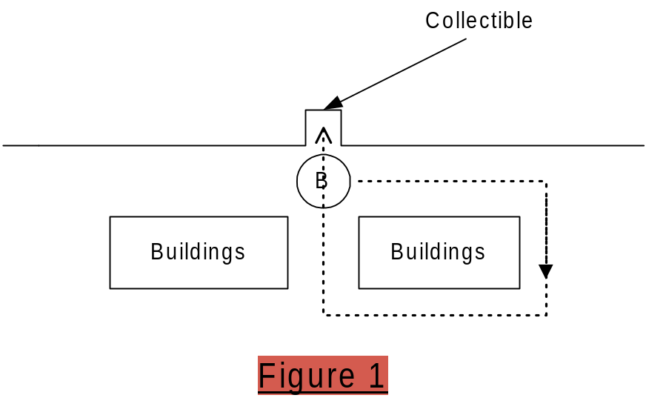

Boss 2 – Through a Maze

Location: Squidport, Krustylu Studios

You lead the Truckasaurus through a simple maze, into a trap (animation & location TBD). Make a wrong turn and you’re toast. The maze area is Krustylu Studios. There will be an animated physics object near the end of the maze that the user has to time right, or they’ll get caught.

Boss 3 – Cage the Truckasaurus

Location: Downtown

Start on-foot. Run to your car, which is pointed the wrong way (i.e., towards Truckasaurus). You have to do a “Rockford” (spin the car at speed) and race down the street. Get out of the car, wait for the Truckasaurus to get “in the zone”, and drop a two-sided gate on him. Miss the timing and he’ll catch you.

Boss 4 – The Homer-saurus

Location: Power Plant, inside the Stadium

In the stadium, control the Truckasaurus with Homer animations, on some kind of rampage mission (TBD).

Boss 5 – Guarding a Place

Location: Squidport

The Truckasaurus is guarding an object at a T-intersection as shown in Figure 2.

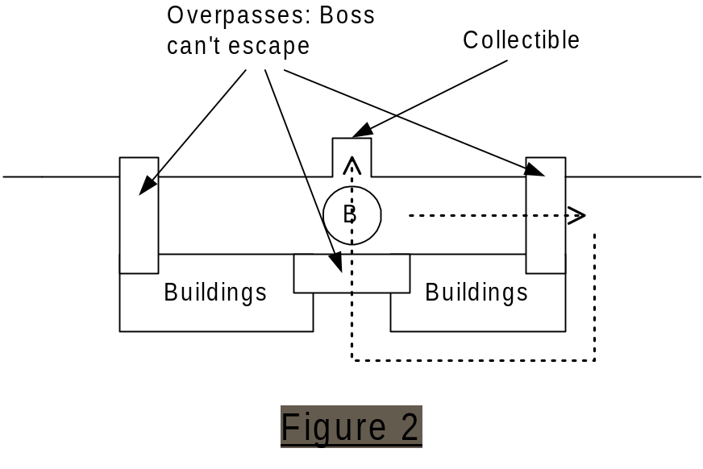
Your objective is to lure him to the end of the block, and then race around the block to get to the collectible object before he gets back there. Overpasses prevent the Truckasaurus from leaving the two streets at the top of Figure 2.

Boss 6 – Cage the Truckasaurus

Location: Downtown

You have to:
- Lure the Truckasaurus to a gate
- Get out and push the button
- Get back to your car before he catches you
- Lure him to the end of the cage, and take an on-foot elevator up to a walkway
- Run to push the door-close button before he escapes

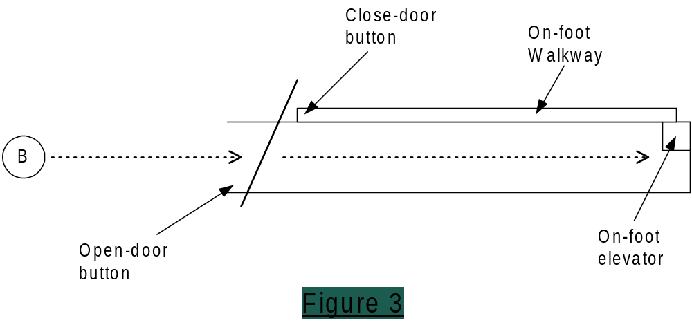

Boss 7 – Through a Maze

Location: Power Plant, train yards

You lead the Truckasaurus through a maze that includes animated physics objects. Lure him into a trap (animation & location TBD). Make a wrong turn and you’re toast. The maze area is the train yards.

Boss 8 – Kill the Truckasaurus

Location: Power Plant, train yards

Inside a stadium, there will be objects (TBD) that allow you to lure the Truckasaurus into a trap, where you’ll get a shot at jumping your car into his head.

Appendix A – Boss Animation

A very smart person suggested that we have just two boss models - Truckasaurus for the regular game and Lardlad for the Halloween level

The only boss character is the Truckasaurus (if we have extra time, we’ll also do LardLad for the Halloween level). Animations we’d need are:

- Mission-start presentation/animation for the boss
  - The same for each mission? Or do we need some mission-specific ones?
- General running and turning
- Chase animations that give feedback on the luring gameplay:
  - Aggressive running (i.e., like in our movie)
  - Getting very close and taking swipes and bites at you
  - Loosing interest if you get too far
- "Guarding" animation (standing and guarding an object)
- Idle animations
- Victory/failure animations, e.g.:
  - He could crush your car in his jaws if he catches you?
  - What if you’re on-foot?
  - What if you get away/win the mission?
- We might have specific animations/NIS for traps:
  - Truckasaurus falling into the water
  - A second trap for boss mission 6?
  - Truckasaurus’ head gets knocked off in final mission?
- A Homer-saurus animation set - the Truckasaurus with Homer animations (i.e., he's in a motion capture suit)
- A Ralph-asaurus animation set - the Truckasaurus with Ralph animations

Multiplayer

Goals

Based on a mini-post-mortem of Road Rage multiplayer, we came up with the following goals:

- Keep the players close together
- More constrained chases – keep the players from separating or getting lost during chases
- Well hidden catch-up logic – keep the result un doubt as long as possible
- More life through character dialog
- Keep opponent visible (e.g., FOV, less speed, HUD, navigation system)
- Physics (collisions, damage, and driving) tuned for multiplayer
- Game data tuned for multiplayer
- Improved frame rate
- Keep it simple – fast, instant action
- Stay true to characters
- Cars move slower
- Balanced chase gameplay – make sure chasing player has fair chance to catch the escaping vehicle
- Design the game world to match these goals

Prioritized Features

- Game Mode: Basic CTF gameplay, with variable locations on the flag but one delivery location per player per gameplay session
  - Front end screen lets you choose your character/vehicle
  - Front end screen to choose:
    - One of four destination bases (all within Downtown level)
    - Bullet Time options (Normal, Slow Recharge, Off)
    - Point to Win (5, 10, 15)
  - The “flag” spawns like the passengers in Road Rage
  - Each player has one destination for a gameplay session (e.g., if you are delivering to the Kwik-E-Mart, then that’s where you’ll always take the flag)
  - You steal the flag by ramming the other player
  - First one to N flags wins
  - Delivery/pickup/steal mechanism the same as last year:
    - One touch pickup/steal/delivery
    - No tag-backs
- “Bullet Time” to create and emphasize player battlers. Components of this are:
  - slow-motion gameplay
  - fade-in transition from full speed to slow speed (and vice versa)
  - Screen blur visual effect accompanies transition
  - Game Logic/HUD, e.g.:
    - Three uses per vehicle, just like single-player powerups (the difference being that all multiplayer vehicles have only one countermeasure – bullet time)
    - User initiated with a button press
    - User’s get back a bullet time recharge (i.e., one of three uses recharges) by the following rules:
      - When the other user picks up the flag
      - When the other user steals the flag
      - When the other user is carrying the flag, and you drive for more then N seconds (tunable) and your bullet time inventory is empty
  - Countermeasure for escapee – some way to easily put the car on two wheels?
  - Tuning tools (amount of slowdown, transition time, recharge rule in code)
  - Sound – what happens in slow motion mode?
  - Camera lock – camera target is the other vehicle when in Bullet time
  - Camera – experiment with full-screen view in Bullet time
- HUD that shows other player (e.g., arrow over their car in the game world)
- Better way of showing who has the flag – vehicle glow or f/x, as is used in first person shooters?
- Taunt button
- No navigation arrow – navigate using the map, and by keeping the other player visible
  - Or do we need a crow-flies arrow or some other way of letting you know where your opponent is?
- Damage system could be catch-up logic – person with flag more susceptible to damage
- AI traffic as catch-up logic – more traffic (or more bad drivers) in front of flag bearer
- Technical question – Can we use out-of-the-car gameplay as the choose-car interface? Racing to and getting in a vehicle of your choice (e.g., four cars are lined up, you have to run – possibly around objects – to your favorite)
  - Put slower cars closer to the characters start location
  - Obstacles for the player to navigate to get the best cars – race for the car mini game
  - Note that choosing a car chooses a character (driver) – so who would you be that doesn’t eliminate a driver choice? i.e., you can’t be Homer, or his car wouldn’t be available. Could use non-driver characters, like dog/cat, itchy/scratchy, etc.
  - Would this limit player vehicle choice? How many of our 16 vehicles can be in the game world at once?

Question
- What are ways that we can incorporate FPS-like CTF strategies and world design?
  - Choke points in the map
  - Choke points under user control – e.g., a switch that raises a drawbridge
  - Physics-based traps you can spring on other player? Block a way?
  - Keeping the vehicles visible as much as possible – open, small world
  - Incorporate vehicle counter-measures like oil slicks?

Tools

Some of the tools designers would need to create this gameplay:
- Maya world-building tools:
  - Place base(s) – two per level?
  - Place flag spawn-locations
  - Place drivable vehicles start locations
  - Place 2 character start locations
- Game-tuning tools:
  - Game rules in code – revise rules based on stationary base
  - Tune counter-measures:
    - Effect (e.g., size of oil slick or smoke screen)
    - Bullet Time (amount of slowdown, transition time, recharge rate, bonus recharge values for special moves like jumping)

Prioritized Content List

- Downtown single-player level design includes a “sub level” – a piece of the level that can be blocked off and used for multiplayer

Driving Model

Goals

- More fluid and natural feel, and reward skilled/experienced players
  - Less tight and twitchy
  - More natural turning/steering
  - More sliding, finer gas/brake control
  - Less “floaty”
  - Not too loose (e.g., Wreckless)
  - Midtown Madness 2 is a good example of the driving feel
- A sense of danger – that feeling that you are on the edge of danger when driving very fast
- More exciting and realistic collisions
- Don’t let the car get stuck
- More variation between vehicles, including vehicle speed
- Trick moves (e.g., drive on two wheels)
- AI cars perform more like user car
- Exciting jumps & big air
- Balanced and tuned physics for multiplayer

Features

- The new driving physics; the new and improved “feel”
- Cleaner, more effective powerslides (close to the one-button touch to initiate slide of Driver)
- Initiate sliding with physics & steering, not just with handbrake
- Technical question – investigate possibility of “rally mode” driving on dirt surfaces
- Analog gas/brake controls:
  - GT3 control option – right stick for full analog has/brake
  - Support two states on button gas/breaks - “hard button press” and “soft button press”
  - Experiment with using one stick for both steering and gas/brake (see XBox Bloodwake for example)
- Full physics simulation on AI cars in accidents
- Suspension physics or animation on nearby AI vehicles
- Special moves:
- 2 wheel driving – some way to get the car up on 2 wheels (maybe while in Bullet Time?)
- “Break stand” – a way of doing peel outs
- Donuts
- Speed Burst (see “Chase AI” document)
- Getting unstuck & collision recovery:
- Automatic tank mode when driving into a wall or collision volume with steering and gas pressed, and the car isn’t moving – user won’t have to reverse. See Midtown Madness 2 (with car in automatic transmission mode) for example.
- Reverse power slides – it’s a high priority to get smooth reverse powerslides as a satisfying way to pull a 180. See GTA3 taxicabs for the quality benchmark.
- The “Weeble effect” to make cars land upright without limited their degree of motion.
- Exciting jumps – with the slower car, and maybe they’re heavier too, be careful not to make jumps too small

Tools

- Tuning tools – cars can be easily tuned (with slider-like controls) in four major categories. The variables will be as independent as possible.
  - Top Speed
  - Acceleration
  - Handling/Stability
  - Mass & strength

Collision Physics

Goals

- Distinguish breakables vs movables
- Visually distinguish breakables/movables from static objects
- Real life impact
- Better/more user control
- Better artist tools & consistent naming directions
- More visually consistent crashes
- Vehicle doesn’t get stuck
- Allow in-game reset without world load

Features

- Lots of breakables is good, it adds life to the world – especially if the user has a reason for hitting them
- Breakables implemented via “delete from world and play animation”, not with physics as in Road Rage
- A movable might also have an animation (e.g., mail box) but object itself doesn’t deform or break
- Breakable and movables must look breakable
  - Immovable objects must look more solid – and be placed outside of common driving lanes (e.g., don’t put a big solid tree on the front lawn of a corner lot that people use as a shortcut)
- “Tank mode” when car pressed up against collision volume (with gas and steering applied) – see Midtown Madness 2 for example
- Realistic impacts – more rebound and shock absorption, as opposed to “two diamonds colliding”
- More forgiving in minor collisions (e.g., where car just nicks a corner of a building and in Road Rage was completely stopped or spun around)
- More consistent reactions to collisions in general – i.e., better correlation between user’s expected result (based on what they see) and what the physics engine produces
- Better way of bouncing vehicle off wall (e.g., sideswipe wall at high speed) without losing so much speed
- Less “floaty” objects
- More variation in mass of world objects (e.g., a parking meter shouldn’t feel as heavy as a street light) – while still maintaining user advantage in these situations; the goal here is variety and a more authentic feel, not realism
  - At the same time, make sure there is NO movable object that the user can get stuck on, regardless of the object’s orientation (e.g., like the Road Rage billboards when lying flat on the ground)
- Experiment with more verticality in collisions – e.g., realistic accident physics, but send cars up into the air
- Reset of breakables and movables on mission restart (implies limited # of object start positions stored in a buffer when they are hit – therefore driving around the world will also cause objects in past locations to be reset in real time)
- Artists need a better tool for ensuring consistent density of objects
- Richer, more varied sound for collisions and vehicle accidents

Design Notes

- Less floaty objects and more realistic collisions means greater user penalty – this means we need careful placement of heavy objects and tuning of traffic system/density

Dialog System

Goals

- Emphasis on character relationships and dialog
- More variety in dialog
  - Re-use Road Rage, Skate, and celebrity re-use rights to provide variety
  - Give priority to using new lines first; supplement them with Road Rage/Skate lines
- More lines based on relationships
- Expand relationship dialog system to incorporate on-foot encounters
- Technically less demand on the load system – more predictability in character and/or dialog selection
  - Prioritize different types of dialog (e.g., “Must Play Lines” and “Optional Play Lines”)

Definitions

- A conversation is a series of lines between two characters.
- A one-liner is a standalone line of dialog uttered in response to a game event. Each one-liner implies a dialog set – a group of 1 or more lines associated with a particular event. If there is more than one line in the set then the game chooses from the lines randomly.
- A walker is a player the user can control on-foot. They can also get into vehicles as a passenger.
- A pedestrian is a character in the world that walks around or stands in one place.
- A driver is a character who drives a car.

There are four types of dialog:
- MPL. Must Plan Lines. These lines are always played. If another line is playing when a MPL event occurs then the MPL line is queued.
- MPI. Must Play Immediately. Used for animation-specific events such as falling or being hit by a car. Any currently playing dialog is cut off and the MPI dialog is played immediately.
  - Note – NIS dialog probably has to be MPI, so that it matches the NIS presentation.
- SPL. Should Play Lines. If other dialog is being played, the OPL event is queued with a lifetime of a few seconds (to be tuned). If the lifetime expires (i.e., while other dialog is playing) then the dialog event is ignored, so that the dialog itself is not separated from the event that triggered it.
- OPL. Optional Play Lines. These are just like SPL, except that optional lines are not triggered every time a given event occurs. For example, not every vehicle damage event should result in dialog, or the characters would never shut up.
  - We’ll need tuning tools to determine how often these lines play (Marc B & Darren E to specify tuning tools?).
  - Ideally, the game would avoid starting an OPL in situations where a MPL line is about to play (e.g., don’t start an OPL in the last ten seconds of a mission, since you know you have to play mission failure/success dialog and presentation).
    - TBD: What are these rules?

Conversations

There are two types of conversations:

- Mission specific. In these conversations we know in advance which two characters are having the conversation, what they will say, and when they will say it. This implies that the world builder tool will include a way to link mission-specific events to specific dialog conversations. Mission-specific conversations are MPL, since they will convey important information to the user.
- Relationship conversations. You won’t necessarily know which character will be involved in advance, so the game will have to know which characters have relationship lines for each other. There is more than one conversation per character relationship pairing, so the game chooses the conversation randomly. Relationship conversations are SPL.

The events that can trigger a conversation are similar (though some are exclusive to mission-specific). If a given event has specific dialog associated with it then that mission-specific dialog is played; otherwise a relationship dialog event is triggered. The triggers and conversations participants are:

- Walker/Driver triggered on walker vehicle entry.
- Walker/Driver triggered on mission objective complete.
- Walker/Pedestrian triggered by proximity to the pedestrian.

For relationship conversations, either participant may start the conversation. For example, Homer may walk up to Bart. The dialog includes conversations initiated by Homer, and others initiated by Bart. The choice of which to play is random.

In Car One Liners

Driver/Walker

This dialog is OPL. The game will randomly choose which of the two people in the car will speak, and choose a line from the dialog set. The trigger events are:
- Big air – vehicle jump of a certain magnitude
- Minor crash (no damage, such as hitting a breakable or low-speed collision)
- Crash causing vehicle damage
- Big crash (e.g., head-on collision causing maximum single-hit damage)
- Near miss accident
- Near miss on pedestrian
- Reaction to hitting a pedestrian
- Car destroyed (implies a few second time penalty before it resets)
- Running out of time in mission (“negative“ Skate dialog?)
- AI chase vehicle closing the gap (“They’re gaining on us…”)
- AI escape vehicle widening the gap (“They’re getting away…”)
- Location-based trigger to comment on something in the world

Walker Only

MPI dialog (i.e., it must match presentation):
- Mission start (in-car)
- Mission start (on-foot)
- Mission victory
  - Specific to bronze/silver/gold rating
- Mission failure

SPL dialog:
- Training lines for the driver, triggered by trigger-volumes placed in world builder by game designers. Mission-specific:
- Smooth starts
- Powerslides (reaction to under-steer into crash)
- Cornering (reaction to under-steer into crash)
- “Rockfords” (reverse 180 powerslide)
- Passenger pickups (how to do them)
- Get too far away and the chase-mission fails
- How to evade pursuers
- How to use countermeasure
- Telling you to switch vehicles
- Instructions to the driver, triggered by trigger-volumes placed in world builder by game designers:
- Turn left
- Turn right
- Go straight
- Turn around
- Go up the hill
- Go down the hill
- Take the jump
- There’s a shortcut
- You’re going the wrong way
- Stop

OPL dialog:
- Exit vehicle
- Reaction to destroying an AI vehicle
- Reaction to using a vehicle counter-measure successfully
- Reaction to using a vehicle counter-measure unsuccessfully
- Race comments (relationship specific?):
  - Pass an opponent
  - Get passed

Driver Only

- Driver car descriptions (e.g., fast and fragile, great control and balanced, or a slow tank). SPL.
  - Plays after the walked/driver conversation the first couple times you get into a particular vehicle? Or triggered by proximity when you aren’t near enough to a door to get in?

On-Foot One Liners

Walker Only

MPL dialog:
- On object collection (object/mission specific)
- On world interaction (reaction activating a button)

Animation Based. Event is in sync with corresponding animation. MPI; must play immediately – cut off other dialog if necessary (i.e., it will look wrong if you are gabbing away and fall or get hit by a car and you keep talking):
- Idle
- Fall
- Get up
- Reaction to running into static
- Reaction to running into character
- Decelerate and turn 180 degrees
- Dodge car (the car missed)
- Hit by car
- Hit by pedestrian (e.g., two people bumping into each other)

Pedestrian

OPL dialog:
- Dodge car (the car missed)
- Hit by car
- Hit by pedestrian (e.g., two people bumping into each other)

Pedestrian Only

MPL dialog:
- Get out of the car / I want to talk (i.e., if you drive up to a pedestrian who wants to have a conversation)

Multiplayer Events

MPL dialog for multiplayer-specific events:
- Flag pickup
- Flag delivery (score)
- Steal or pickup the game-winning flag
- Steal the flag
- React to stolen flag
- Win game
- Dialog for bullet-time?

MPI dialog:
- Taunt
  - User initiated
  - Specific to game context, four situations:
    - Losing
    - Winning
    - Game is close
- Carrying winning flag

Date Issued: March 12, 2002 Document Issue: 0.1
Document Status: Draft Filing Path: Perforce: RADFS1:1675

Document Title: Simpsons 2: Preliminary Sound Design Document
Author: Marc Baril
Keywords: Sound design, Music, Voice, SFX

Revision History

Issue | Date | Person | Reason - include problem #, ECN #, etc.
0.1 | March 12, 2002 | Marc Baril | Initial draft of document.
1.0 |  |  | First official release of the document after internal review by …

Table of Contents

Sound

Goals
Emphasis on character relationships and dialog
  - More variety in dialog - more lines based on relationships
Thematic music – specific music for each playable character (e.g., stingers at the Road Rage game-over event) chase music
Use sfx and ambient sounds to create more dynamic worlds.

Voice

Direction
The character’s voices were a big part of the game’s success. Our goal is to improve and add to that feature.The game designers have outlined the high level design such as:
  - Passenger-to-driver interaction
- Character relationship dialog for pedestrian events
- Characters dialog that recognizes world locations
Voice is certainly the most important sound feature if not the most important aspect of the Simpsons license itself. The technical demands for the voice in the original game were huge. We must design the voice in a way so it is more predictable in terms a sequence of events so the system knows which line of which character needs to be loaded at any given point. Having a hierarchy such as the “must play lines” and the “optional play lines” would help make the sound system more efficient and allow us to allocate sound resources to other important sound assets.

Type definition
Finale design TBA

Driver character

Passenger character

Pedestrian characters

Implementation / Tool requirements
In order to maximize the sound in the game the dialog system must be categorize properly.

Driver character

Passenger character

Pedestrian characters

H2H

Voice Data management

PS2, GC
On the PS2 and GC, it will definitely need to be done dynamically with 2 buffers (more if we can) The game would have to anticipate and load data ahead of time to play on the demand. If loading can not be done ahead of time, a delay of up to 1.25 second.

X-Box
The X-Box has the advantage of the hard drive which we hope to use for dialogue.

Scripting Tool:
We will not be using any special tool for the dialog. Once the naming convention will be established the sound programmer will write a program that will parse the files and do all the conversion for all platforms. We will use RadTuner to test, trigger and tune the dialogue content independently from the game triggers. In the same tool we can tune levels and control variance in the playback.

Risks / Concerns / Problems / Solutions

Scheduling
Scheduling of the voice talent, recording and editing is the most significant dependency of this game. We rely entirely on FOX for this and we have no control. It is imperative for FOX to schedule the voice talent recording sessions as early as possible to make sure the game will not be delayed.
Note: Recording must be done by September 15th, 2002.

Localization:
The assumption is that we will receive edited sound files ready to add to the game. We will do the mastering of the voice only.

Car sfx

Direction
The overall direction with the car sounds remains the same as it was in Road Rage. The intent is not to simulate a real car, but rather to create a fun and responsive driving experience.
We will be looking at improving the current engine code. We will likely re-use previous engine sounds but we will create new engine sounds appropriate for each of the new cars type and size. The main distinction will be in the performance and the car upgrade features, we will tune the cars for each incremental levels of performance.

Type definition

Engine sounds
Here are the parameters for the engine sound system
- Trim (master volume)
- Max volume
- Min speed (minimum speed required for playing a sound, i.e. surface sound of gravel will trigger only if the car is moving)
- Pitch increase (maximum pitch increase)
- Pitch decrease (minimum pitch increase)
- Looping (on/ off)
- Engine “normal” RPM (establishes the reference RPM value at which the engine sound wave will play non altered)
- Decay time
- Delay time
- Attack time
- Inside cone angle
- Outside cone angle

Road surface
tires on dirt, water, grass surface etc.

Skids, tire squeal
peelout (tire squeal sample for a peel out)
skid (skid sound used for hard turns, spin outs and sudden stops)
hand brake
normal brake
donut

Car horn
horn (sound of the car’s horn)

Implementation / Tool requirements

Engine sounds
Although most of the cars will use different samples, they will all have the same four components.

Road surface sample
Surface detection, surface id

Skids, tire squeal
There are only two types of skid sounds that will be used. Skid and peel out sounds will be global across all cars.
The first type is the peel out. The peel out sound will behave in a way such that it gets louder as the wheels spin faster.

Peelout sample

Car horn
Each car will have it’s own horn sound. There will be only one horn sound per car. Depending on the car, one of two kinds of horn samples could be used. Some of the cars will have a one shot sample assigned to the horn. This means that if the player holds down the horn button on the controller, the horn sound will play until it reaches the end of the sample, at which point it will stop. The other kind of horn sound will use a looping sample. This will be used for some of the more obnoxious characters in the game (such as Homer or Barney). The looping sample will allow the user to hold down the horn button and have the horn play for an indefinite period of time.

Risks / Concerns / Problems / Solutions

SFX

Direction
The sfx will done in the traditional cartoony style, over the top but always in check with the TV series. There are a number of episodes to which we will refer to assure consistency with the TV show.

Type Definition

Collision Sounds
Those are basically all the impacts sound. The samples will be organized in categories of wood, metal and glass crashes. We will combine the various samples for the various types of objects.

Small objects
Wood crates, park bench, mailbox, fire hydrant, and garbage cans, etc.

Immovable objects etc
Building, trees etc.

Landing
Car hitting the ground with a bouncy springy sound.

Collision with other cars

Generic Driving sounds

Road surface
Driving through water, grass, dirt road

HUD sounds
Game timer, collectible status, countermeasure use, vehicle damage status

AI car sfx

Simple Engine sfx, car horn, tire squeal. Refer to car section for more details.
The difference here for those sounds is they attached to a moving object controlled by the AI.

Implementation

Collision Sounds
Triggering condition: collision + object id
Control: volume to speed of car, position
In the case of the landing sequence, we have to find out if it is an canned animation or controlled by the physics of the car.

Generic Driving sounds

Road surface
Triggering condition: surface detection
Control: depending if speed is constant on those surfaces

HUD sounds
Triggering condition: HUD id object + condition TBA
Control: none

AI car sfx
Triggering condition: car id object + proximity
Control: Doppler fx (pitch, volume to velocity) , position

As far as the horn of AI cars we will to see if we want to figure out how to do this with individual cars or just when crossing busy intersections.

Tools requirements

Audio for Run-time collision physics system
The random variability of a collision simulation is graphically stunning but it is the variability that makes traditional game audio applications ineffective. A single ‘canned’ sample triggered with each simulation will never be synchronized with the graphic and seem wrong because the audio is fixed while the graphic randomly varies.
We have recently developed audio support for our run-time collision physics system. The system relays info pertinent to audio such as the behaviour of the objects, land, bounce, spin, slide, roll and also the gemometry, as which part of the object as collided. Based on that info we are then able to associate sounds with each object type and have sound matching the dynamism of the collision.

Risks / Concerns / Problems / Solutions
If the Ftech support for the run-time collision physics isn’t completed on time we would have to revert to the more traditional approach of canned collision sounds.

Music

Direction
The music will have a more important role to play to help telling the story and support the presentation. In Road Rage, the music was more incidental and it was played back as a jukebox. This time we will associate specific music tracks with specific missions and have more music written for each of the playable characters.
Search and explore music, the in-between mission music will need to be fun foot tapping music in a style that would suit each of the 8 playable characters (very much like what Chris Tyng did for the game over short stinger in a musical style representative of each of the character, but this time in full length pieces of music)
For instance, when you play Lisa some kind of jazzy saxophone music plays until her mission kicks in, at which point a more dramatic music track would then be cued according to the mission level and intensity. There has to be a clear distinction between the search and explore mood and the mission music. We could very well re-use music from last year for the chases since it is doubtful we will be able to get 20 new songs for the game.
The personalized short stingers from Road Rage could also be re-used, new ones would need to be created for the new characters. They were created for the game over segment so we would need also need a “victory” version of each of those. There would be eight mission failed stingers and eight victory ones – one for each controllable walking character.

Type definition

In-game Music
The various mission will require different type of tracks.

Search and explore
2-3 tracks written for each character. Music style that would suit the 8 playable characters.

Chase music
10-12 different chase type music with various level of intensity. Most tracks done for Road Rage would actually be better suited for this year’s game.

Short stingers

Mission succeed / fail
Unique succeed and fail music stinger for each of eight playable characters

Win H2H
2-3 short stinger when you win in H2H

Implementation

In-Game Music
The music should be coded to work in jukebox style. No particular order, flag the tracks once they are played, play all other tracks before playing the same one.

Win H2H
Play the short win stinger with the winning sequence

Unlock screen
Play the short music stinger when unlocking something

Risks / Concerns / Problems / Solutions
As always, dealing with an external composer has the potential in delays and not getting what we require for the game. This time around we should try to have direct contact with Chris Tyng to ensure we do get the right music and have a chance to review and hear the work in progress early enough so we can give him feedback on how it works in the game.

Front End

Direction
The current game design has a minimal Front End. It will comprise of 3 main screens (and the options screens). We will have a short title track (30-45 seconds?) depending on the final story; the music could be thematic to set the tone of the game.

Type definition

Navigation sfx
Select, scroll, back, cancel, reject (for locked up levels)

Implementation / Tool requirements

Navigation sfx
Triggering condition: joystick input, screen #

Cheats:

Triggering condition: cheat fail, success

Risks / Concerns / Problems / Solutions
None

Ambient and Landmark Sounds

Direction
We are currently considering having no music when stepping out of the car. The music would then be replaced but an ambient track such as city ambience, ocean sound with seagulls for the Squid port etc. This would help make the game more dynamic and more alive than having music throughout the game. (We could possibly use minimal and sparse underscore kind of music)
Adding landmark sounds and world based sound would greatly help to make the environment alive as well.

Type Definition

World based sounds
Such as water falls, nuclear generator etc.

Landmarks sounds
Those are soundbites we will associate with specific buildings in the world. They will be about 10 seconds long, one shot samples.

Implementation / Tool requirements

World based sound
Those sounds are loaded in a buffer and played based on the proximity of the object. Those type of sounds are expected to always play (i.e. driving close to a water fall should always be heard)

Landmarks sounds and other ambient sounds
These sounds are also played through a buffer system however they don’t have to play every time. (probably should not, unless if it is desired as in the crow sound when entering the nuclear plant compound) An example of as sound attached to a landmark would be the school bell. Driving by the school you occasionally hear the school bell ringing etc. Other types would be generic sounds to be triggered randomly such as dogs barking in the suburbs, birds etc, those types are associated with a neighborhood and are triggered only if nothing else are a higher priority is required. These types of sound enhance the worlds but they are lower priority and should always be secondary if dialog is required to play.
Triggering condition: proximity to a sound making landmark + landmark id
Control: Doppler fx, 3D positional (panning)

Tools
The easiest way to implement this is to use the model developed in Dark Summit. With the aid of a debug camera, the sound designer is able to navigate anywhere in the world and display the names of objects. Then he can edit the object file and associate a sound with any desired object. The sound gets loaded and unloaded automatically as he approaches and leaves the given object.

NIS / FMV

Direction
There will be 16 FMV that will play at the beginning and end of each level.

Type definition

Intro
Intro NIS to the level

End of level
End NIS of the level

Implementation / Tool requirements
None

Risks / Concerns / Problems / Solution
See voice Risks section
The animators will need to animate to the recorded dialog. Which means they can’t finish their work until we have received the files.
Another consideration is the localization of those FMV. For the best result, all the languages would to record to the finished FMV which might not be possible.

Memory management

PS2
Here is the current plan for managing the sound memory on the PS2.
RAM = 2 MB of compressed data 4:1 (so close to 8 MB
Hard drive= No
Multiple CD streams= Possibly
- One partition for universally used sfx (collisions sfx, AI cars, HUD, etc.)
- 4 buffers, 2 for loading dialogue (one passenger, one driver), 2 for landmarks sfx. Don’t exactly yet what we will do in H2H since it will depend on the dialogue design. (more buffers if we can)
- Car sfx bank (budget the space for the largest bank X 2 to cover for H2H)
- Hopefully 2 CD streams, one for music the other for ambience

X-BOX memory management
The access to a hard drive will help us greatly on the X-BOX. Memory in this case could be divided as such.
RAM = 8 MB ( hopefully, less if can cache from hard drive)
Hard drive= Yes
Multiple CD streams= DirectMusic is supposed to allow this easily

- One partition for universally used sfx (collisions sfx, AI cars, HUD, etc.)
- Instead of using buffers for loading and playing dialogue, landmarks sounds, we could put on the hard drive and cache the data.
- Car sfx bank (budget the space for the largest bank X 2 to cover for H2H)
- Hopefully 2 buffers for CD streams, one for music the other for ambience

Additional Features

Reverb
We will use reverb and other DSP capabilities to process sounds when going through tunnels. For this we will need to create groups of sfx. For instance, a car + voice of the driver (and passenger if it applies) should be grouped together so if the player goes through a tunnel, sounds triggered by that car and the voice of its occupants will be processed with reverb accordingly and independently from the music or the other sound triggered say by another player in H2H.
We now support reverb for all the platforms.

Dolby Surround
Dolby Surround is a well-known multi-speaker playback system that requires special encoding as well as additional hardware at the user end to be able to experience it. This method is “canned”, perfect for movies but not design to be interactive.
The X-Box however, supports real-time surround encoding and this is done by the hardware. For example whenever a car is behind you the sound will be automatically played through the back speakers of the surround system. Of course, to experience this feature the X-Box must be connected to an amplifier with a built-in surround sound decoder like most entertainment system and have the proper speakers setup.
The other platforms do not support it and therefore will not have real-time surround sound. (The PS2 is our primary SKU; XBox and GC specific features like this one are low-priority, to be done if there is extra time.)

Presentation

Goals

Major goals:

- Choose a style for our game (e.g., the movie “Snatch”) and use it throughout
- Utilize The Simpsons style as well
  - Camera cuts rather than camera swoops
    - Be careful to maintain continuity and context between cuts
  - Short scenes – camera changes every 5 seconds (or less – subject to research/analysis of Simpsons style)
- Camera composition and purpose
  - Use the camera purposefully – no floaty, meaningless camera swoops
  - Show off the world – use conversations and other presentation elements to frame the better world art

Minor goals:

- Better tools – plan and coordinate roles of artists, designers, and coders
- Don’t violate TRC requirements – specifically, everything can be paused
- Allow movies to be skipped (possibly with a confirmation overlay, as in Jak & Daxter)
- Fully specify HUD animation
- Use sound to augment presentation – for example, stylized sound effects for slow motion and accelerated-time shots; see The Matrix, Snatch, and Max Payne as reference examples
- Don’t use cuts on world interaction presentation – need to show relative location to the user; do use presentation style though – for example, the accelerated-time + slowed-time cuts used in Snatch

Content

- The movie “Snatch” as the presentation style of the game
- Simpsons theme during transition
  - Character specific music
  - Short transitions
  - Keep scenes under 5 sec
- Camera styles include:
  - Multiple cuts
  - Zoom in and out
  - Pans
  - Tracking
  - Camera rotation (camera spine)
- End of mission transition
  - Skid to stop
  - Victory/failure animation – could use a camera cut and place the character outside of the vehicle
  - What about the transition back to mission start location?
- Investigate high resolution models for NIS
  - How long to load?
  - Will it fit with the presentation style?
  - Don’t sacrifice presentation style for higher resolution art
- Facial animations for conversations under procedural control:
  - Mouth flapping
  - Eye blinking

Features

MAIN STORY – pre-rendered.

Level (Episode) start - pre-rendered.

Mission start - procedural

- There are approximately 75 possible missions
- Darryl doesn't think we can do the snap shot 2d image (similar to Snatch) during an in-game sequence.
- Also, 75 images will be a lot of work to do. Was not expecting this.
- Darryl will look into a snapshot image in game held in memory for a few seconds. And in black and white.
- Possible Scenarios
- Talk to character
- Get into car
- Drive car to location
- Presentation ideas
  - Screen blur
  - 2D (monotone) image
  - Mission title
- After mission start dialog
  - Dissolve to:
    - 2-3 second camera pan
    - Sound effect (to signify mission about to start)
    - HUD appears

Mission Success - Procedural

- In car
  - car will skid to stop
  - 90 degree turn to highlight passenger (User)
  - Possible scenarios
    - camera cut
    - camera rotation
    - text on screen
  - Slight pause to load
  - dialog
  - character specific animation
  - Sound F/X

Issue: roof

- Out of car
  - Text
  - Slight pause to load
  - Character specific animation
  - Dialog
  - Sound F/X

MISSION FAILURE
- In car
  - car will skid to stop
  - 90 degree turn to highlight passenger (User)
  - Possible scenarios
    - driver kicks you out of car
    - car explodes
  - camera cut
  - dialog
  - character specific animation:
Issue: roof

- Out of car
  - Text
  - Character specific animation
  - Dialog
  - Sound F/X

CONVERSATIONS (100 -150 conversations)

There are two types of conversations:

- Simple quick dialogue that really doesn't pertain to gameplay
  - In game
  - No camera change
- Key mission objective dialog. Conversation between charaters where they are getting information on gameplay hints.
  - In game
  - Player can leave conversation
  - Procedural
  - Camera presentation effects
    - Cut
    - Zoom
    - Boarders

Issues:
- In order for this to work, technically the characters have to be in position for the dialogue to trigger (also, some sort of indicator or highlighter)
- Issues of objects may obstruct the camera view, solution would be to make sure objects do not exceed passed the camera height where the major dialogue takes place.

Level end
- Similar to mission success.
  - Car or character does victory animation
    - Car skidding to stop
    - Character specific celebration animation
  - Text to indicate success
- Fade to load screen. We may have to have two, one before the FMV and one after. In that case one load screen could be the summary of level stats and the other could be the chalkboard.
- Fade to FMV

Issues:
- movie player is a lot to load. NIS may be better. don't know if we can use chalkboard

World interaction and trigger result
- Triggers will be highlighted using some sore of color and indicator.
- Once activated there will be a procedural camera pan to show the result. The screen will be letterboxed to indicate loss of user contol.

COUNTER-MEASURES
- speed burst will have a blurr effect
- bullet time will have a fish eye effect similar to star wars
- oil slick will be indicated by sound and a camera shake to indicate a crash behind you
- Look back button will be used to help with chase and evade game play

MULTIPLAYER
- Similar start to single player
  - Straight fade from front end, camera pan, a three second count down then gameplay
- On victory the winners screen will become full screen and that person will have a small victory animation

Tools

- Support Maya cameras? Would allow for iteration on camera movements in Maya.
- Designer/artist placement of cameras that are controller procedurally:
  - Cut cameras on jumps
  - Conversation cameras
  - Mission-complete presentation

Character Animations

Idle Animations:
Homer:
- Scratch head
- Scratch bum
- Fall asleep and drool/ snore
- Burp
- Pull out and eat beer/donut
- Twiddle Fingers nervously
- do the "i'm missing the chili cook-out" anim from last game while saying something like "ohh... i have to go to the bathroom."
Marge:
- Adjust hair
- Twiddle fingers
- Pull something from hair
- If carrying Maggie, set her down
- Pull something from hair
- If carrying Maggie, set her down
- Tap toe and look mad/ impatient
- comb hair

Apu:
- Adjust jacket
- Comb over hair
- Tap foot
- Pull up pants
- Levitate - Cross legs and mediate
- pull out pricing gun and stick pricetags to the surrounding area

Grampa:
- Fall asleep
- look around like he's lost
- adjusting false teeth in his mouth, like they're about to fall out
- take medication

Bart:
- Sling-shot
- Cross arms (inpatient)
- Eat butterfinger
- hunch over and look around like he's about to cause mischief - holding slingshot
- Laughing (kind of devilish when he as a devious idea)
- light a firecracker and toss it

Lisa:
- Tie shoe
- Pull out SAT book
- Look at watch
- Yoga
- Swat fly
- play saxaphone
- pull out some sort of apparatus like gps or compass or map

Ralph:
- Pick nose
- Pick up “bug”
- Leprechaun appears on shoulder
- Pick ear
- Fingers in mouth
- curl up on the spot and sleep like a puppy
- skipping (but looks like he's totally in another place while he's doing i
- run in circles and bark like "wiggle puppy"

Milhouse:
- Has to pee - "have to pee dance" and raise hand
- Adjust glasses
- Adjust underwear
- Laugh
- accidentally drop glasses and fumble blindly on the ground trying to find them

Mission Failure (on-foot)
-dialog
-character specific animation
Homer
- Does his Doh expression and sound
- hunch shoulders and wince

Marge
- Marge does her dissapointing Hmmm.
- tap toe and crosses arms
Apu
- Curse you and your capatist, meating eating ideology (Apu's deep)
- crosses his hands and looks pissed off at the camera
- hands over face, hunched over - "oh... I have brought shame to my store and my family"
Grampa
- Does not even know whats going on·
- begin to remese about the war staring into the sky
- begins to tell you what s was like in the "old days"
Bart
- Slams his fist on the ground
- Hangs his head and slumps shoulders forward
- stares at the user pissed off with hands crossed
- stares at user and says "get bent"
Lisa
- Proclaim that the game was unfare and that if she was more "popular" it owuld hev been easier
- shakes head in hands
Milhouse
- Starts to cry - "i want my real father!"
- waves hands in the air runs in a tight circle
- starts to shake/vibrate - "IIIiii'''mmmmm fffrrrreeeaaaking ooouuuttt!!!"
Ralph
- Sings Happily like he actually won
- waves hands and jumps for joy
- picks nose - "i found a moonrock in my nose"

Mission Failure (in Car)
-car will skid to stop
-90 degree turn to highlight passenger (User)
-Possible scenarios
-driver kicks you out of car
-car explodes
-camera cut
-dialog
-character specific animation:
Homer
- Bash head against steering wheel
- Road Rage - Do's and bangs on the dash
Marge
- Shakes her head and covers her face in dissappointment
- embarassed looks around and hunches to make sure nobody saw what she did, giggles in hand
Apu
- throws arms up and looks to the sky asking my Vishnu tests him so???
Grampa
- oblivious to anything looks around and just asks "what?!!"
Bart
- raises hand to forehead, shakes head in disgust.
Lisa
- Crosses arms, bitterly disappointed , stares mad at the road, trying to move it with hypnosis
Milhouse
- completely freaks out - arms waving, head gesturing - screaming "why me, why me???!"
Ralph
- Raises his hand in the car and asks "teacher? I'd like to go to my happy place now"

Mission Success (on-foot)
Homer
- raise fist in celebration
- who-ho's - pumps fist "I'm number 1" or "USA"
Marge
- raises her arms in the air
- embarassed, looks around to see if anyone noticed (yes, same as failure, differnt sound)
Apu
- PUts his hands together and bows.
- puts hand together in prayer looks to sky - "oh thank you Vishnu!"
Grampa
- Grampa still doesn't know whats going on. Huh?
Bart
- Jumps in the air with one fist striking in the air
- "...and still the Champion"
Lisa
- skips up and down and shouts yeah
- claps repeatedly excited
Milhouse
- again, crazed excitemtent then looks aorund calmed, and hunches over cause nobody cares
Ralph
- stares blindly and gives an completely unassociated comment - " I like you? do you like me?"

Mission Success (in-Car)
-car will skid to stop
-90 degree turn to highlight passenger (User)
-Possible scenarios
-camera cut
-camera rotation
-text on screen
-dialog
-character specific animation:
Homer
- gives a thumbs up
Marge
- Waves out the side of the car
Apu
- nods his head
Grampa
- still doesn't know what happened
Bart

Lisa

Milhouse

Ralph

Animation

Goals

- More lifelike characters
- No “zombie” expressionless characters
- Better presentation of animation

Features

- Idle character animations
  - More movement, including head movement
  - Specific to each character
- Eye blinking (under procedural control) for all characters in the game
- Mouth flapping when speaking (except for generic pedestrians)
- There are three classes of conversations and associated presentation:
  - Quick, minor conversations – use a variation of the gameplay camera to indicate to the user a temporary loss of character control
  - Important, longer in-game animations – full NIS with custom animation and camera work specific to the conversation
  - Eight story setups and resolutions – full FMVs with high detail character models and facial animation
- TBD – full range of character animations needed for smooth character control

Content

Eight Walking (User Controllable) Characters

Each user controllable character will have animations for:
- Idle state (doing nothing) – a very important animation that should be exaggerated (see Mario 64 and Banjo-tooie for good examples); include head-panning
  - Blink
  - Mouth flapping
  - Look around
- Walk
- Run
- Turn left/right
- Left/right 45 degree turn
- Lean left/right (while running)
- Decelerate and turn 180 degrees (e.g., Bart skids to a stop, turns, and runs the other way) – this animation will be specific to the character’s body type (e.g., child, woman, fat man, etc.)
- Reaction for bumping into solid surface (wall, etc.)
- Reaction for bumping into a character
- Get knocked down by vehicle
- Get up
- Falling (off ledge)
  - Flail
- Activate switch
  - Kid
  - Adult

Sixteen Drivers

Driver animations:
- Turn around (when reversing the vehicle)
- Turn left
- Turn right
- Decelerate
- Accelerate
- Wave
- Wave goodbye
- Idle (includes head panning)
- Bounce in reaction to vehicle movement
- Sway left (in reaction to vehicle movement)
- Sway right (in reaction to vehicle movement)
- Crash

Passenger Animations

Body Specific:
- Point left
- Point right
- Point straight ahead
- Look back
- Look left
- Look right
- Get into car
- Get out of car
- Bounce in reaction to vehicle movement
- Sway left (in reaction to vehicle movement)
- Sway right (in reaction to vehicle movement)
- Idle (include head panning)
- Cheer
- Crash
- Catapult out of car

Issues:
- Characters getting into cars
- Characters opening doors
- Big vehicles (Duff truck)
- Kids (doors open automatically?)
- Adults (animation to open door?)
- Use camera cuts
  - Key on driver
  - POV of Passenger
  - POV of driver

Pedestrian Animations

Same as Main character animations with the addition of:
- Bump into person (reaction)
- Get knocked down by vehicle
- Get up
- Reaction, when about to be hit by vehicle (cowering)
- Idle
- Flail
- Dodge
- Near miss (angry)
- Dodge (flatten against wall)

Game Interface (HUD & Map)

Head Up Display (HUD)

Goals

- Simple, effective, animated presentation of the information the user needs

Features

- The information the user needs on the HUD is:
  - Map for navigation, including location of collectibles and AI opponents
  - Counter-measure availability and use indicator
  - Damage meter
  - Speedometer (question: digital or analog?)
  - Indication of collectible requirement/status for multiple collectibles, e.g., if you have to deliver or destroy N objects
  - Mission objective (text? Or just character dialog?)
- The map, damage meter, and counter measures can all be shown in one simple HUD object as in Smuggler’s Run 2:
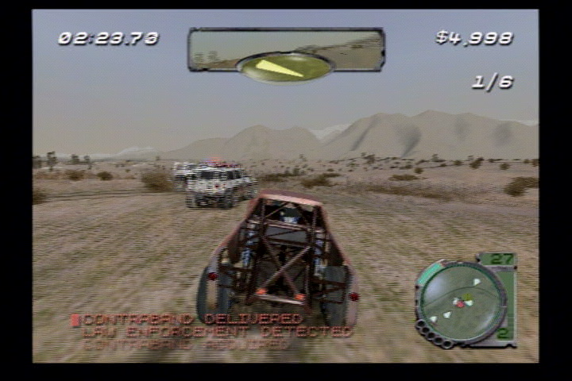
    - Simple animation (flashing) on counter-measure light when it’s used (or recharged)
- The collectible status will glow or pulsate, with a sound effect, when it is updated
- A timer – this is one of the most prominent HUD elements, since time will be a factor in most missions.
  - Simplest solution is a simple digital counter
  - Needs animation (e.g., blinking red) and sound, both of which increase in frequency, as it nears zero – same system and logic as Road Rage should work fine
  - If there’s a way to make it prominent enough, it can be part of the HUD map “object” – but it may be hard to read? Does it need to be separate “floating” text? Same issue applies to collectible status.
- We need presentation for mission success/failure events and one aspect of this requires HUD art and animation – the “mission status” reward that the user earns:
  - There will be four levels of success – like the gold/silver/bronze in other games
  - The 4th rating is “skipped”; if a user fails a mission ten times in a row we will ask them if they want to skip it
  - There will be character animation and presentation for the mission-complete state; can we add an object to this presentation to indicate status? e.g., plain donut, chocolate donut, donut with sprinkles?
  - We need to think of the reward for completing the game at silver or bronze
    - Maybe it’s an additional gameplay mission in the Halloween level

Tools

- The simpler the better. All we should need to tune is animation around collectible status update, timer, and mission success/failure text

Player Navigation (Map)

Goals

- Simple and consistent - always works the same way from the user's POV
- Error free - never points in the wrong direction
- Flexible – allows for user choice of path when we want it to (e.g., missions with multiple pickups and user choice of the order)
- Low learning curve for the user

Features

- The HUD map displays one or more target icons. If it’s off-map, then it slides along the edge of the HUD map.
- NO arrow on the HUD as in Road Rage.
- Map icons are removed when the user picks up the item or completes the objective.
- The pause screen will show a large version of the map as the default pause function.
- The map will rotate to match the user’s orientation (on both the HUD and pause screen) as in Road Rage and Midtown Madness 2.
- Targets, including moving ones such as AI vehicles, will have a highlight arrow floating over them in space. The arrow is “3D” in that it gets larger the closer you get.
- Mission-specific navigation instructions, verbally issued from passenger to driver. For example, hit a particular collision volume and Bart, as the passenger, will say to Homer, “Turn left, Dude!”
- General world (not mission-specific) instructions from passenger to driver (e.g., “I think that’s a shortcut”)

Design Notes

- The first few missions in the game must be carefully designed to slowly teach the user how to navigate in the game world.

Tools

- Designers can lay down mission-specific collision volumes that are linked to navigation instructions, for example:
  - Turn left
  - Turn right
  - Go straight
  - Turn around
  - Go up the hill
  - Go down the hill
  - Take the jump
  - There’s a shortcut
- Designers can lay down similar information that’s always in a level, not mission-specific. This might be useful for pointing out shortcuts or other world features.
- Each walking character will have dialog for these instructions (might be able to reuse some Road Rage dialog).

Front End Interface

Goals

- Minimalist. The over-riding goal is to reduce scope – spend our time on the game, not the front end.
- Get the user through it as quickly as possible.
- Within the constraints of the above goals, make it look great.
- Within the constraints of the above goals, make it simple for the User.
- No bitmaps with text on them – all text in a text bible
- Implement the Front End in the quickest way that will produce a high quality result

Features

- The only functional requirements of the FE is the ability to choose:
  - Continue latest saved game – takes you directly to the latest save location using the consoles internal clock
  - New Game – Create a new game in one of eight available save slots
  - Load game – loads one of eight available saved games (separate screen)
  - Multiplayer – goes to a screen that lets you choose your multiplayer settings. From there you go to the choose vehicle screen (or level, if we have more than one level)
    - The important element of this screen is to show the vehicle ratings – i.e., so that both users can pick a “fast” vehicle if they want
  - Choose the options menu (see Options section of this document for details)
- The options screen is also minimalist – it will be presented like the pause screen, with simple text menus.
- Animated “Help text” for menu items, explains each item in more detail
- TRC requirements (TBD – controller and memory card requirements and restrictions – e.g., disabling head-2-head if there’s only one controller)
- Text bible approach from say one – no bitmap text
- Special effects for FE screens and Pause/Options menu:
  - Flashing text to indicate highlighted object (see Smuggler’s Run 2 for a good example)
  - Sounds
  - Music

Controls
For all platforms, the start menu will be used to enter a pause menu. While in a pause menu or in the front end, the following controls will be used:

Controller section
- Users must be able to start the game with any supported controller on any controller port. Once started, users must not be required to switch controllers or controller ports to play the game. The controller plugged into slot 1 will always be player 1 and the controller plugged into slot 2 will always be player 2, 3 = 3, and 4 = 4.
Loss of Controller
- Within one second of the loss of an in-use controller, the game must suspend the game in progress if such a feature is supported (ie. Pause feature).

Playstation 2
- X will be used to advance or make a selection
- Δ will be used to go back to previous screen
- The directional pad will be used for navigation

Xbox
- A button must select the current option, confirm action, invoke the selected action, or move to the next menu.
- B button and the BACK button must cancel an action, dismiss a menu, or return to the previous menu.
- START button may be mapped to the same functionality as the A button, or it may perform a more appropriate action (such as quick-starting or leaving pause states).
- The directional pad must be usable for navigation

Gamecube
- A button must select the current option, confirm action, invoke the selected action, or move to the next menu.
- B button must cancel an action, dismiss a menu, or return to the previous menu.
- The control stick and control pad will be used for navigation

Flow
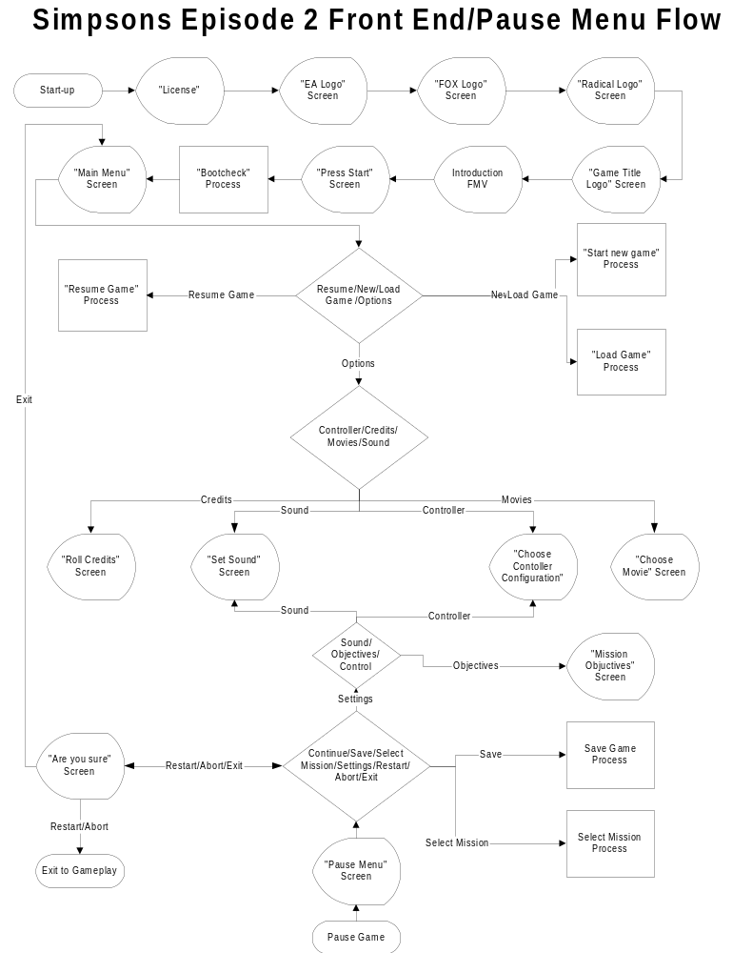

Continue Latest Game
Continue Latest saved game will only be accessible if, during the boot-up process, a previous game has been detected and there is sufficient space. If these qualities are met, then you will proceed from the latest save location of the most recent game.

New Game
The New Game option will take you straight to game play starting at the beginning of the game. The User will have to save from the pause menu. If all eight save slots are filled and they wish to save their new game, then they will have to overwrite one of their previous saves.

Load Game
The Memory card/Hard Drive will be divided into 8 Slots allowing for 8 possible different games to be saved. Games will be saved according to the following naming convention:
- Date
- Time
- Level
- Mission
Once a selection is chosen, the user will be taken directly to the game, commencing from the location they just loaded.
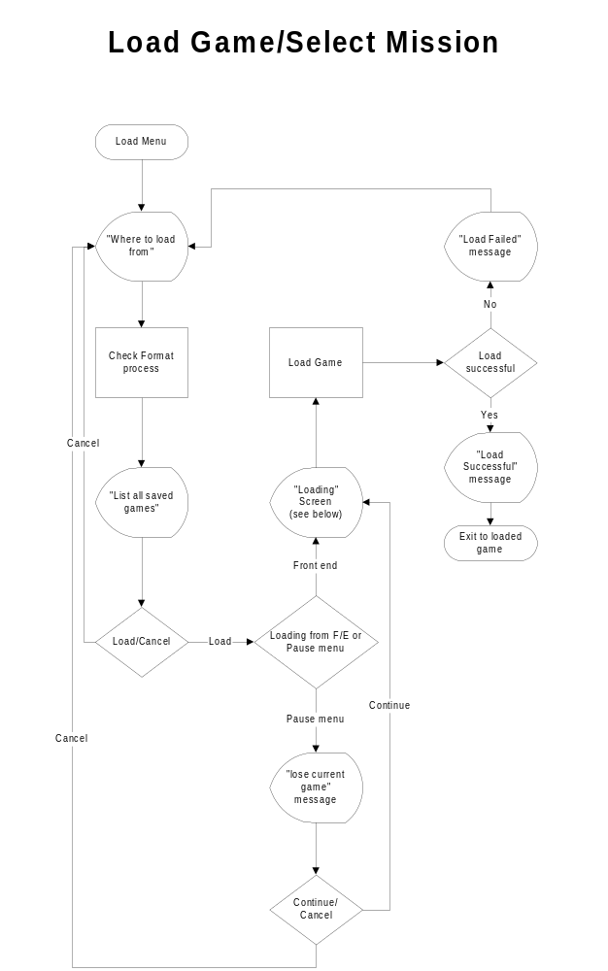
If a User wished to select a specific mission that they passed in a particular game, they would have to load that game, enter the gameplay, press START and choose Select Mission from the PAUSE menu.

Select Mission
The select mission option will provide a similar function to the Load Game, however it will only be accessible from the pause menu. It will allow a user to go back and play any mission that they have previously passed on the loaded game.

Multiplayer
The multiplayer front-end will try to get the players to the game as quick as possible. From the main Front end screen, the Users will be taken to the Multiplayer Setup Screen. Here Users will be able to set things such as:
- Different home bases
  - Lard Lad donuts
  - Police station
  - Moe’s
- Counter measures setting
- Number of points they would like to play to.

From here they will go to the Select Character Screen. The select character screen will have a multiplayer interface (more than one player may pick a vehicle at one). Player two will have to activate their controller by pressing any button or by simply moving the control pad/stick. The following information will be displayed:
- Character thumbnails (with a visual cursor for selection – color coded for players 1 and 2)
- Car Statistics
  - Speed (Hoarse power)
  - Turning ability
  - Weight (Durability)
- Car Picture (static)

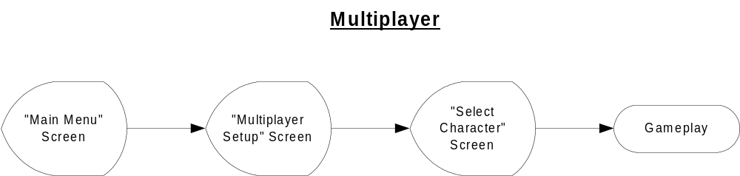

Options Menu

This menu should consist of plain art and simple, clear text. The functions are

- Controls Configuration – allows the user to decide between two predetermined controller configurations (separate screen). Similar to last year.
- View Movies (separate screen)
- Game Credits (separate screen). Similar to last year
- Sound (separate screen). Similar to last year
- Vibration On/Off (Toggle)
- Camera (Toggle).

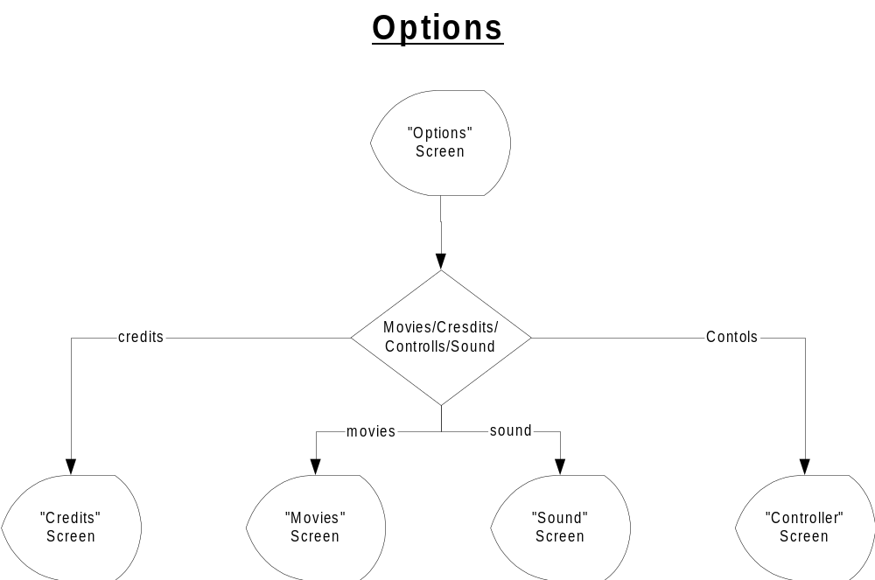

Pause Menu (Single Player)

- Continue – Resume game
- Mission Info – lead you to a different screen containing all mission information including: objectives, tasks, progress, etc
- Mission objectives ( tell you the objectives of the current mission)
- Show Map ( a larger version of the Level Map)
- Save – lead you to a different screen allowing the user to save the game to the memory card and/or hard disk.
  - TRC concerns
  - Save menu contains eight slots for User games
    - Default to latest or loaded game
    - Games are identified by Date, Level, Mission (Not User defined)
- Select Mission - allows you to choose any completed character/mission – will likely cause a game/world load.
  - If you go back to an earlier mission, we need to “clear out” memory of which save file the current user is using, so that it does not get over-written unless the user explicitly says so
  - Shows eight icons representing the walking character at the beginning of the missions for each level (e.g., Bart’s head for the Bart level)
- Options
  - Vibration on/off
  - Controller Configuration – same as Road Rage
  - Sound Settings – same as Road Rage
  - Camera Choice – same as Road Rage, but possibly without “Far” camera
- Quit Current Mission – restart from Sunday Drive mode
- Restart Current Mission – restart from beginning of mission
- Exit – return to main Front End

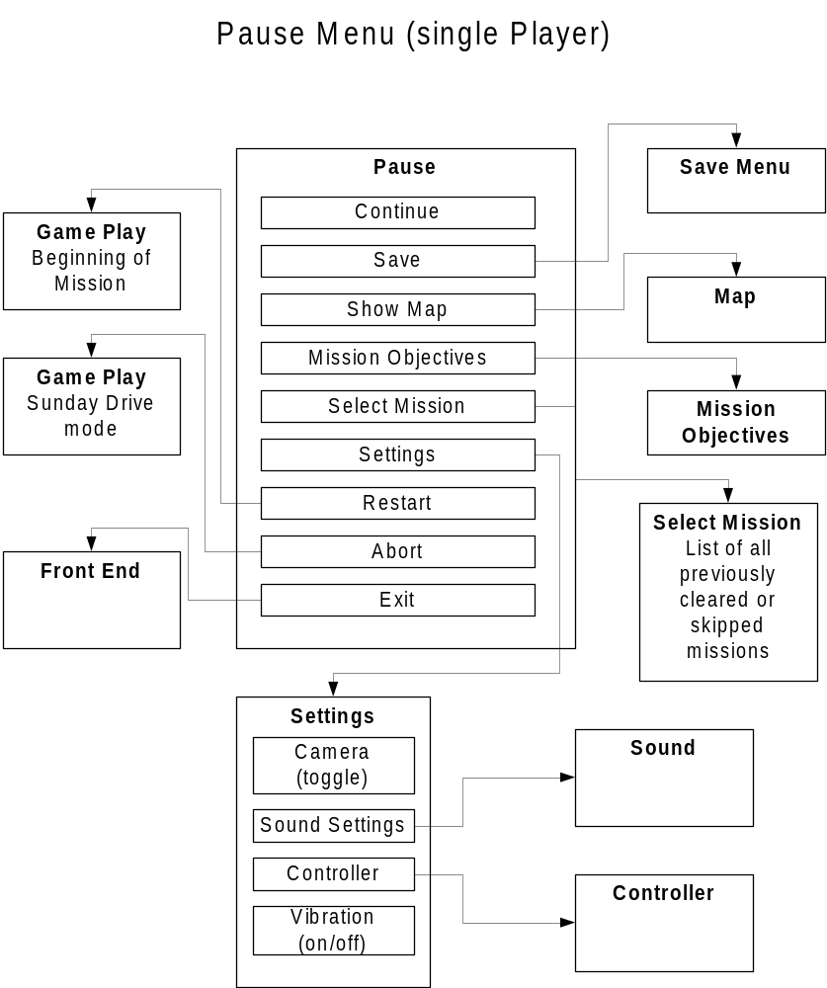

Pause Menu (Multiplayer)
The Pause during multiplayer should look and feel similar to the single player pause. It will contain the following:
- Continue – resume game
- Show Map
- Options
o Vibration on/off
  - Sound Settings – same as Road Rage
  - Camera Choice – same as Road Rage, but possibly without “Far” camera
  - Controller Configuration
- Restart Head to Head – restart from beginning of mission
- Exit – return to main Front End

Memory Card (TRC Requirments)
Please see the Memory Card Section 21 in this document.

Menus

Generic
1. Generic Yes/No
2. Generic General Message (x=ok)

Memory Card
1. No memory card. proceed?
2. Memory card not formatted
3. Memory card Damaged
4. Memory card contains corrupt data
5. Not enough memory
6. Game requires nKB. Initialize?
- File successfully initialized
- Game successfully loaded
- Load failed
- Game successfully saved
- Save failed
- Loading…

Main Menu
1. Main Menu

Multiplayer
1. Multiplayer Set up
2. Multiplayer Choose Character

Options
1. Options
2. Controller configuration
- View Movies
- Game Credits
- Sound

Pause Menu (single player)
1. Pause Menu (single player)
- Mission Objectives
- Select Mission
4. Save Screen
5. Map
6. Select Mission
7. Sound Settings – same as Road Rage
8. Controller Configuration

Pause Menu (multiplayer player)
1. Pause Menu (multiplayer player)
2. Options
3. Sound Settings – same as Road Rage
4. Controller Configuration

Game Over
- Game Over (single player)
- Game Over (multiplayer)

Total = 36

Tools

- Use text bible approach from day one

Content

- Music
- Ambient sound effects
- Constant theme
- Keep it simple

Memory Card & TRC Interface

This section contains flowcharts for the memory card interface and other TRC requirements for the three platforms.

Goals
- Keep it simple; the game is targeted at a casual audience.
  - Avoid filename or other complex interfaces.
- Auto-load most recently saved game upon boot-up.

Boot Up Process

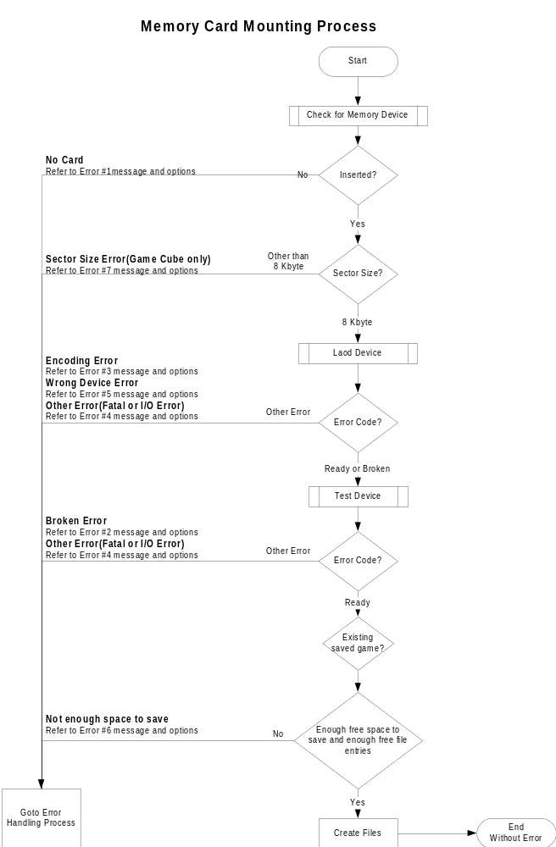

Error Handling Process

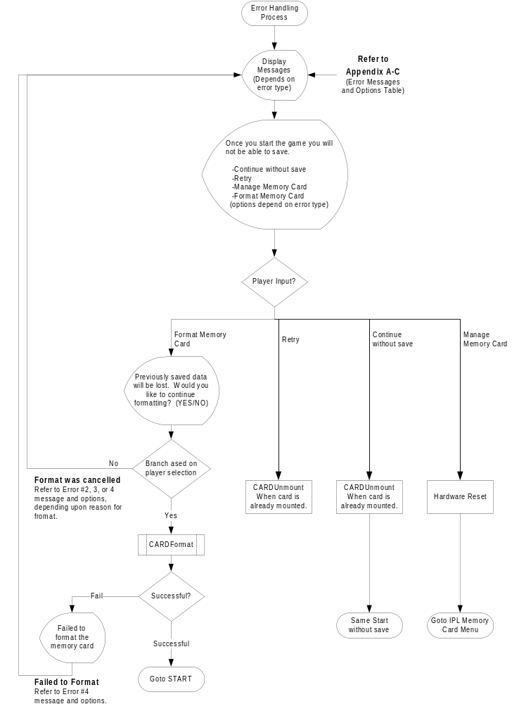

Load Game

Save Game

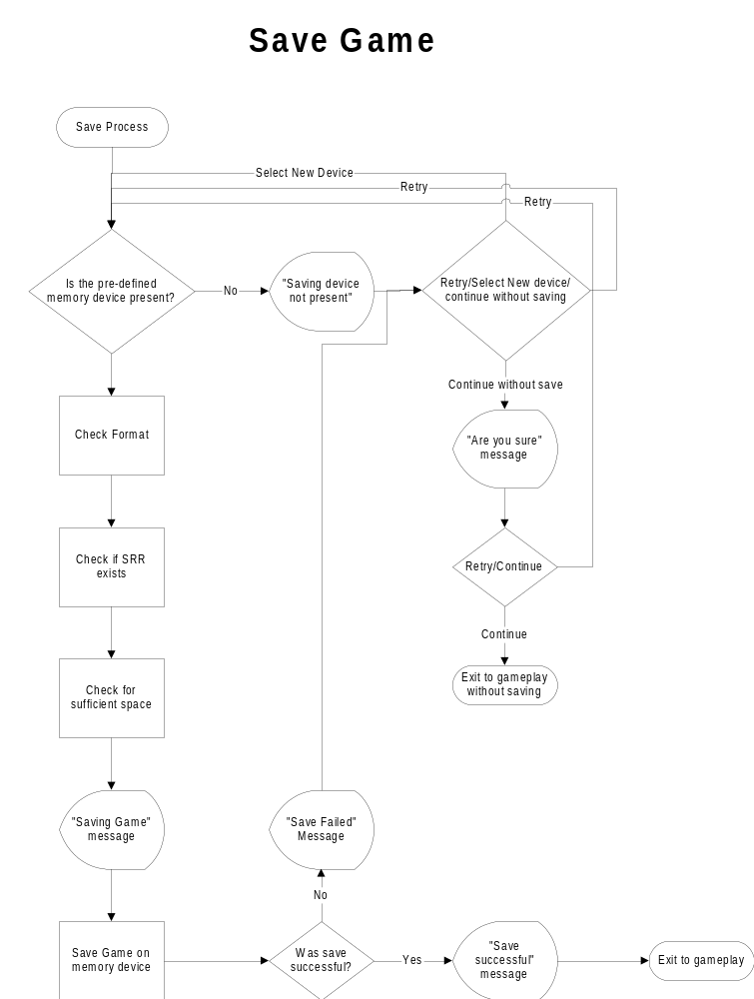

Appendix A (Error Handling messages for Game Cube)

Error Number | Error Type | Message | Selectable player Options
Error Number | Error Type | Message | Continue without save | Retry | Manage Memory Card | Format Memory Card
1 | No Memory Card inserted | No Memory Card found in Slot <A or B> | X | X | --- | ---
2 | System area is corrupted | The Memory Card in Slot <A or B> is corrupted and needs to be formatted. | X | X | --- | X
3 | Formatted for another market | The Memory Card in Slot <A or B> is not formatted for this market. To Save the <Game Title> file, you will need to format the Memory Card. | X | X | --- | X
4 | Failed to format Or Physically damaged | The Memory Card in Slot <A or B> is damaged and cannot be used. | X | X | --- | ---
5 | Device other than Memory Card | Another device in Slot <A or B>. Please insert a Memory Card. | X | X | --- | ---
6 | Not enough space to save | There is not enough space on the Memory Card in Slot <A or B>. In order to save <Game Title>, Y files and X blocks are required. | X | X | X | ---
7 | Other than 8 Kbyte sector size | The Memory Card in Slot <Aor B> is not compatible with the <Game Title> save file. | X | X | --- | ---

Appendix B (Error Handling messages for PlayStation 2)

Error Number | Error Type | Message | Selectable player Options
Error Number | Error Type | Message | Continue without save | Retry | Manage Memory Card | Format Memory Card
1 | No Memory Card inserted | Memory card (8MB) (for PlayStation 2) is not inserted into MEMORY CARD slot 1 | X | X | --- | ---
2 | System area is corrupted |  | X | X | --- | X
3 | Formatted for another market | Memory card (8MB) (for PlayStation 2) is unformatted. Do you want to format? (YES/NO) | X | X | --- | X
4 | Failed to format Or Physically damaged |  | X | X | --- | ---
5 | Device other than Memory Card |  | X | X | --- | ---
6 | Not enough space to save | There is insufficient space. At least xx KB is needed to save this game data. Do you want to start? (YES/NO) | X | X | X | ---

Appendix C (Error Handling messages for Xbox)

Error Number | Error Type | Message | Selectable player Options
Error Number | Error Type | Message | Continue without save | Retry | Manage Memory Card | Format Memory Card
1 | No Memory Card inserted |  | X | X | --- | ---
2 | System area is corrupted |  | X | X | --- | X
3 | Formatted for another market |  | X | X | --- | X
4 | Failed to format Or Physically damaged |  | X | X | --- | ---
5 | Device other than Memory Card |  | X | X | --- | ---
6 | Not enough space to save | Your Xbox doesn’t have enough free blocks to save games. Press A to continue without save of B to free more blocks. | X | X | X | ---

